
Office of Research Compliance

PROJECT CLOSURE GUIUDE

If you need assistance, please email the irb@bgsu.edu (Human Subjects) OR iacuc@bgsu.edu (Animals). Make sure to include the project number, title, PI Name. If you are not the PI, CC the PI on the email.

- Log into IRBNet (http://www.irbnet.org).

- Click on “My Projects” and click the title of the project you want to modify.
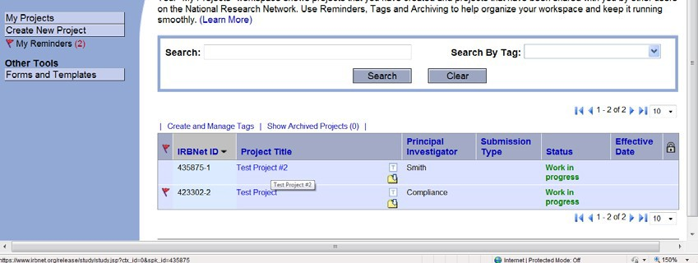

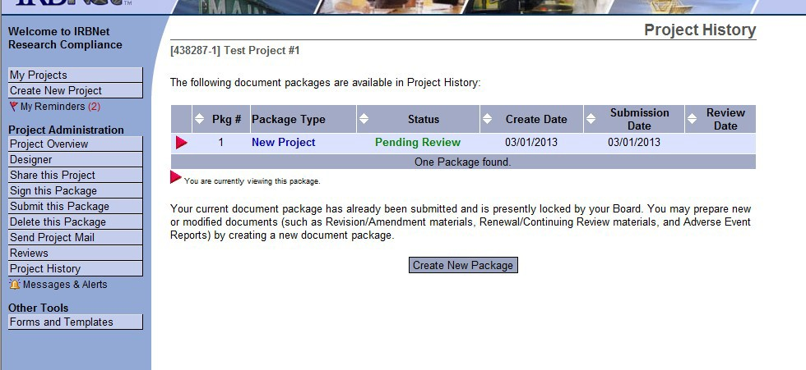
- Click on “Project History” located on the left-hand side of the page. Then click “Create New Package”.
Step #3b
Step #3a

  - Click the “Project History” tab again and choose “Work in progress (not submitted)”.
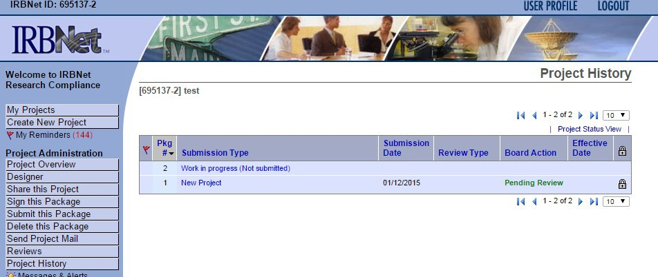
Step #3c

- Click “Work in progress (not submitted)” to begin adding or revising documents.
  - Click “Need Forms? Show Form Libraries”

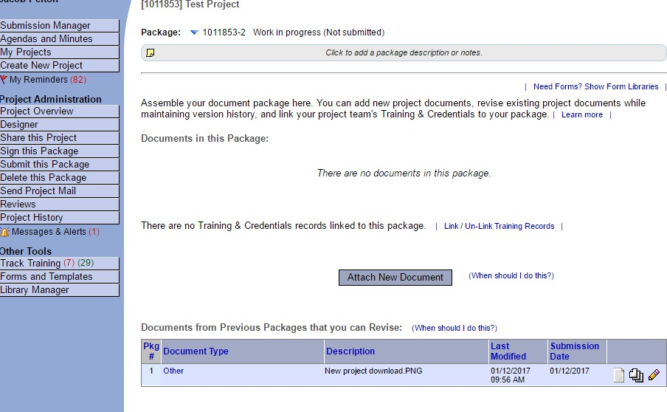

    - In “Step 1”:
      - Download the “Forms – Continuing Review/Closure Form” to your computer. This will ensure that you are using the most current versions of the IRB forms.
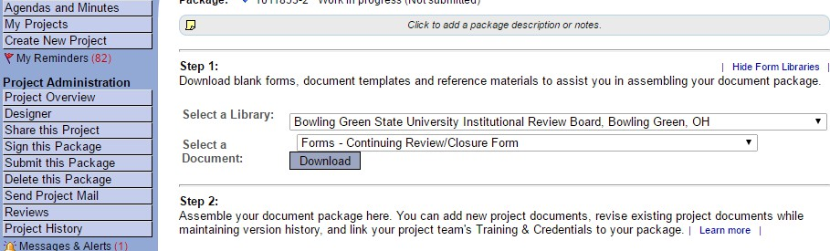

      - Once the Continuing Review/Closure form is completed, click “Add New Document” to upload the completed form.
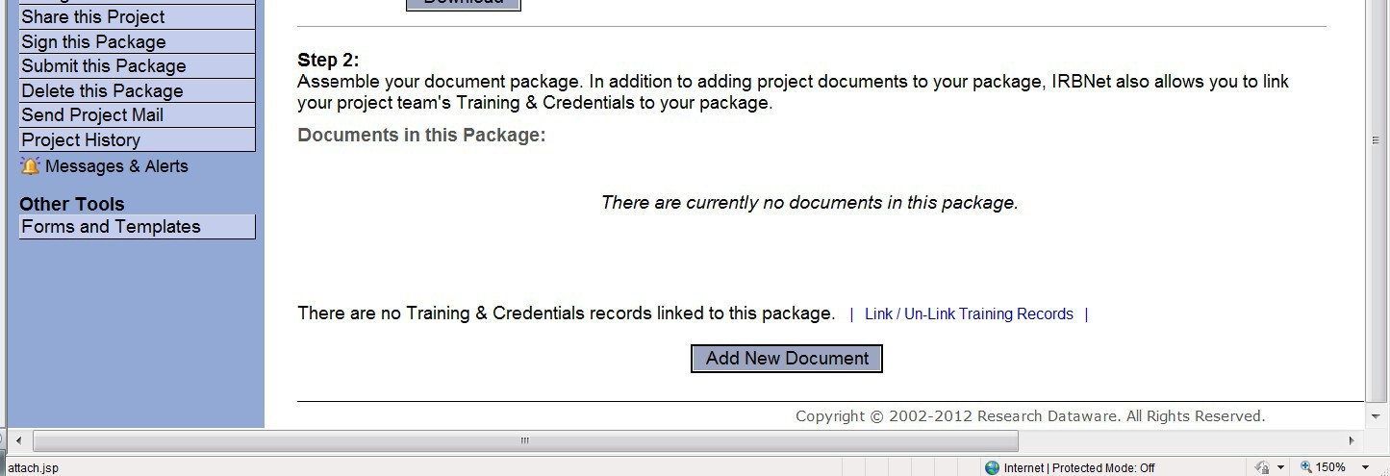

    - In “Step 2”:
      - To upload the consent documents used during the past year, click “Add New Document”.
      - When uploading new or revised documents, select the “Document Type” and “Browse” for the file. Then click “Attach”.
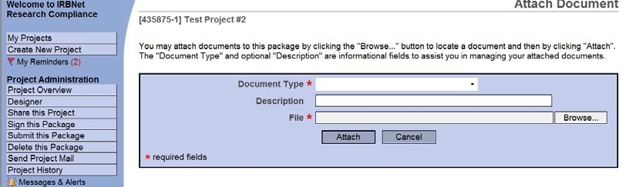

- Sign the package. PIs (and faculty advisor, if the PI is a student) must sign the package before it is submitted.
- Click on the “Sign this Package” button located on the left-hand side of your screen. Select your role, and click “Sign”.
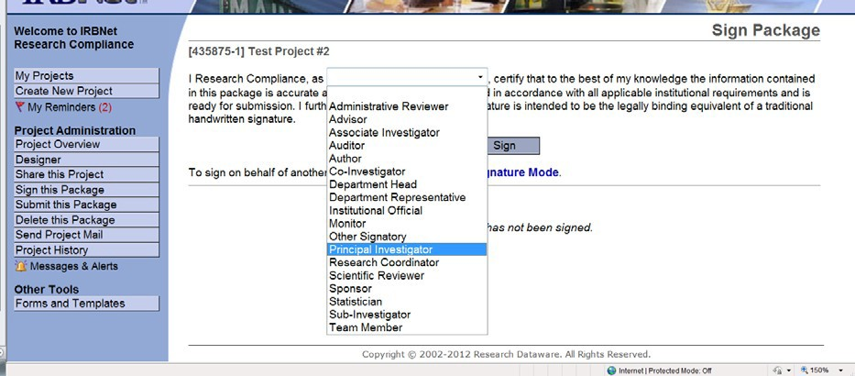

- When your project is ready to be submitted to Board. Click on “Submit this Package” button on the left-hand side of your screen.
- Make sure that “Bowling Green State University Institutional Review Board, Bowling Green, OH” is highlighted in the “Select a Board” box. If it is not, type the word “BOWLING” in the “Search for an Organization” box and click “Continue”.
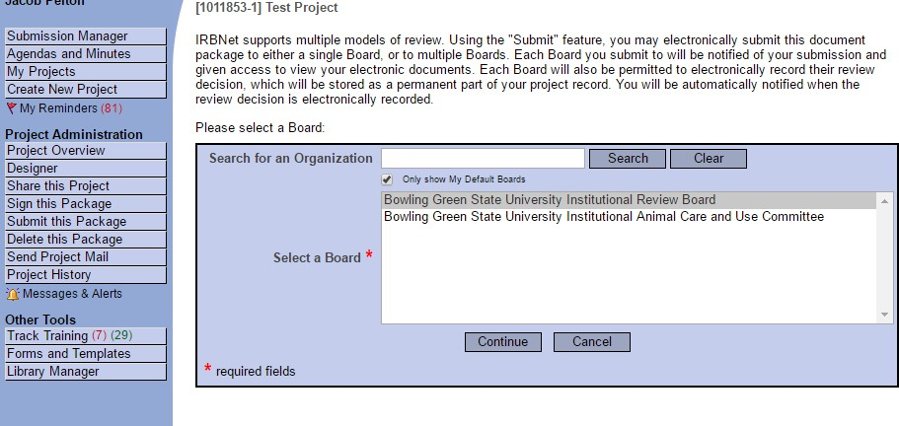

- In the “Submission Type” drop-down menu, select “Closure/Final Report” and click “Submit”.

