Navigating College Executive Summary – Fall 2024
Bowling Green State University (BGSU) undergraduate Student Learning Analysts (SLAs) from the Office of Academic Assessment conducted this assessment project. The SLAs designed a focus group protocol to gain insight about how undergraduate students transition, acclimate, and navigate college at BGSU. The SLAs facilitated four focus groups with 27 participants from varying class standings and majors from five colleges and one undecided participant. Out of the 27 participants, 62.96% (n = 17) self-identified as female, 33.33% (n = 9) self-identified as male, and 3.70% (n = 1) self-identified as non-binary From the race/ethnicity information the participants provided, 77.78% (n = 21) self-identified as White/Caucasian, 14.81% (n = 4) self-identified as African American/Black, 3.70% (n = 1) self-identified as White/Hispanic, and 3.70% (n = 1) self-identified as White/Latina. Zoom was used as the online meeting platform, and the focus groups were recorded. These recordings were then transcribed and analyzed. The steps in the analysis process included: 1) open coding, 2) focused coding, and 3) identifying themes and subthemes.

Students received the following survey prompt when signing into the focus group: “Please list the top 3 BGSU resources and services that have helped you figure out college.” Their responses to this survey question, along with other resources and services that were mentioned in the focus groups, are detailed in the word cloud below, with the larger the word the more often it was said.

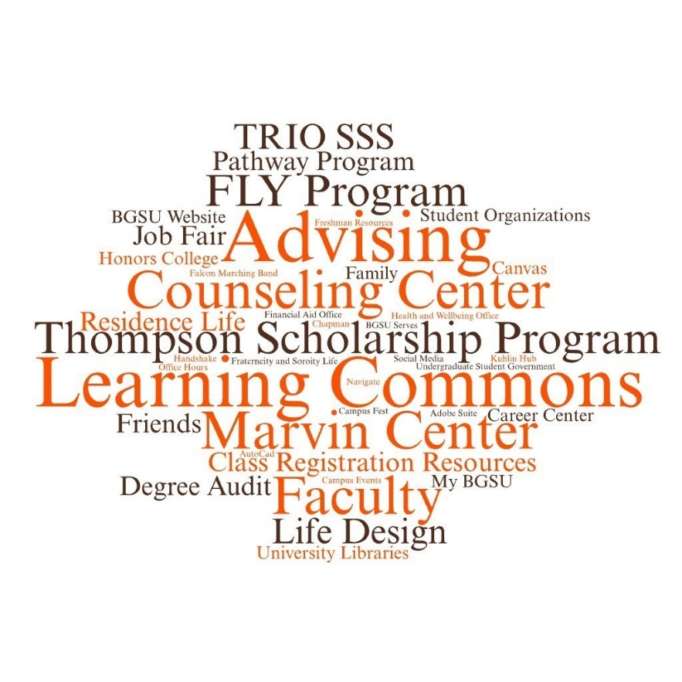

As further data analysis took place, five major themes emerged: 1) College Life,
2) Connections, 3) Development, 4) Support at BGSU, and 5) Suggestions. These themes provided insight into students’ experiences while navigating college.

1. College Life – Students discussed various aspects of being a student at BGSU.
  - Transition – Participants compared their high school experience to their college experience.
  - Navigating Campus – Participants discussed finding their way on campus and figuring out living on campus.
  - Academics – Participants talked about their classes, picking majors, and studying.

An overall quote for this theme is where one student talked about how they view the college experience:
I think about... navigating, and I also think that you know, just like most trips, everyone has like a different path that they follow to, you know, get to where they're going... and ... a lot of people ... have sort of different challenges and the things that they have to do to ....get to the end goal of starting your career and all that. (T2, L26-30)

2. Connections – Participants explored building relationships with people on campus and engaging in the BGSU and surrounding community.
- Peers – Participants discussed making friends and building relationships with other students.
- Engagement – Students described their experience being part of the BGSU community and participating in events, programs, and clubs.
- Networking – Participants spoke about connecting with faculty and staff about future career opportunities.

One individual discussed how connections impacted their experience at BGSU:
I would say making these connections has overall improved the experience as it’s made me more confident in myself and my abilities. (T1, L218-219)

3. Development – Students expressed the different ways they have grown and improved during college.
- Skills – Students talked about types of skills gained during their time at BGSU, such as time management, leadership, communication, and professional skills.
- Challenges – Participants discussed roadblocks and struggles in college and how they overcame or are trying to overcome those obstacles.

A student spoke about something they learned after coming to college:
I know before coming to college, asking for help was, like, a little bit harder, like, kind of intimidating. But when you get to college, you realize it's okay to ask for help and there's like so many resources like tutoring or you can go to, like, the TA's office hours. It's okay to ask for help and use what's available to you. (T4, L102-106)

Throughout the focus groups, students discussed the many different skills they have used or gained during their time at BGSU. Below is a word cloud that illustrates the skills they mentioned, with the larger the word, the more often it was mentioned:
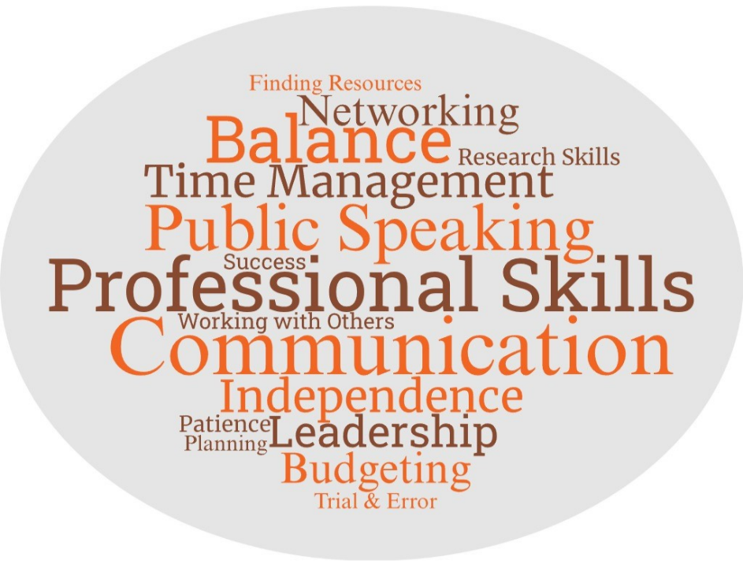

4. Support at BGSU – Participants expressed ways that BGSU assists and helps students.
- Communication – Participants discussed how students were made aware of support resources, programs, and events.
- Resources and Programs – Participants talked about the types of resources and programs that support students.
- Advising – Students discussed meeting with their academic, scholarship, and honors advisors.
- Faculty – Participants talked about professors and administrators who help students.
- RAs – Participants noted that resident advisors assist students in various ways.

An overall quote that encompasses this theme is a student talking about having a support system at college:
I think by having a support system it, like, helps you not feel, like, so alone, especially if you're coming from to college and you don't know anybody or anything. It kind of just helps you and, like, helps support you. (T1, L45-47)

5. Suggestions – Students provided recommendations for students and BGSU overall.
- Peers – Participants gave advice for other students who are learning to navigate college at BGSU.
- BGSU – Participants expressed possible resources and improvements that BGSU could make.

One participant discussed resources that can be added and improved upon:
I think that there are always more resources that can be offered, such as bulking up the Counseling Center more, making tutoring more accessible, offering more free specialized classes at the … Recreation Center, more shuttles to other areas of town, things like that. (T4, L285-288)
For more information about this assessment project, please contact Dr. Jessica M. Turos, Associate Director of the BGSU Office of Academic Assessment, at jmturos@bgsu.edu

