Executive Summary – Student Engagement Fall 2024
Bowling Green State University (BGSU) undergraduate Student Learning Analysts (SLAs) from the Office of Academic Assessment conducted this assessment project. The SLAs designed a focus group protocol to gain knowledge about student engagement at BGSU. The SLAs facilitated four focus groups with 30 participants from varying class standings and majors from six colleges. Out of the 30 participants, 76.67% identified as female (n=23), 20.00% as male (n=6), and 3.33% as transmasc (n=1). From the race/ethnicity information participants provided, 73.33% self-reported their race/ethnicity as White (n=22), 13.33% as African American/Black (n=4), 3.33% as Hispanic (n=1), 3.33% as White/Hispanic (n=1), and 6.67% as Not Provided (n=2). Zoom was used as the online meeting platform, and the focus groups were recorded. These recordings were then transcribed and analyzed. The SLAs used a three-step coding process, which involved open coding, focus coding, and theme identification. Five themes with their corresponding subthemes emerged throughout these discussions and are highlighted below.

1. Marketing – Participants discussed communication strategies on campus and how students became aware of engagement opportunities.
- People – Students noted learning about engagement opportunities from friends, peers, professors, and advisors.
- Online – Students mentioned how social media, websites, and email made them aware of engagement opportunities.
- Events – Students talked about how campus activities and recruitment programs helped them learn about engagement opportunities.
- Information Accessibility – Students discussed flyers and varying levels of communication for campus engagement opportunities.

One student talked about many of these subthemes as they applied to their involvement on campus:
...I came in early and I joined the marching band, which is obviously a really big community right now. I've asked a bunch of people, like, what they're interested in, what they've been doing, and they've had so many people across different majors and everything … Like, there's just a bunch of variety, and it's so easy to find people that have something completely different to what you're used to. And I found a lot of things at Campus Fest that were really useful. Different communities, different organizations. If there's anything that was, like, even remotely close to what I like or enjoy, I would just click the interest form and join them. (T1, L11-18)

Another student noted a variety of ways marketing has influenced their involvement:
I also followed a lot of places on Campus Fest, so I usually check Instagram through that. And then I'll also hear about a lot of things from my different friends. (T1, L338-339)

2. Use of Time – Participants talked about how students prioritize and use their time.
  - Academics – Students talked about how classes and homework fit into their schedules.
  - Jobs – Students noted how work and volunteer experiences affected their schedules.
  - Personal – Students provided their thoughts on how one’s own tasks or desires worked into their priorities.
  - Number of Engagements – Students expressed a number or range of engagements that they felt comfortable being involved in.

This student mentioned how their variety of obligations impacted their use of time:
I am also a 4th year so I am student teaching and I live off campus, and I have a job and I am part of a group on campus. So, I feel like it's just really about finding, like, designated time to do all the stuff that you need to do and plan out what needs to be done first. And then still making time for the organizations, but also prioritizing yourself. And this year that's been really hard, just because I am so busy. But … I feel like it's just about prioritizing what needs to be prioritized and not people pleasing as you prioritize. (T2, L212-218)

3. Professional Development – Participants discussed bringing about future career success through experience and relevant connection making.
- Experience and Skill Building – Students talked about gaining applicable skills through their participation in career related experiences.
- Networking – Students mentioned making connections with employers and students for career purposes.

One student talked about being involved on campus to build career connections as a first-generation college student:
I joined the orgs that I'm involved in because neither [of] my parents went to college, and so I needed to find a way to build a connection and learn about [my major] in general. So, I think those are my main reasons for joining them. (T4, L59-61)

4. Comfort on Campus – Participants discussed how students acclimate to, engage in, and enjoy campus life.
  - Well-being – Students expressed finding comfort through accessibility, inclusivity, community, and focusing on mental health.
  - Interests – Students discussed the role prior interests, academic clubs, and community-based organizations play in their campus life.
  - Making Friends – Students talked about connecting with peers to enhance their campus experience.
  - College Experience – Students noted wanting the most out of college, having fun, and getting their money’s worth.

This student mentioned that they felt most comfortable after establishing a routine and being with friends:
I definitely agree with that with being more comfortable after I got, like, my schedule set in stone. And I also felt a lot more comfortable when I was joining them with other friends, so I didn't feel like I didn't know anybody in the group. (T1, L104-106)

5. Suggestions – Participants brought up ideas on how to improve student engagement opportunities on campus.
  - Information Accessibility – Students mentioned ways to improve communication for campus engagement opportunities.
  - Increased Opportunities– Students talked about ways the University could improve the opportunities available for students and how students can best take advantage of these opportunities.

One student requested that campus implements a quiz that provides students with organizations that might interest them:
There's just a lot of organizations on campus, and it's hard to find out about all of them. So, this might sound silly, but when you take those little quizzes online that tell you what your job could be, things like that. I think that we could do something like that where you put in your interests and, like, your major, things like that. And it would say what clubs might be applicable to you. (T4, L265-269)

Infographic

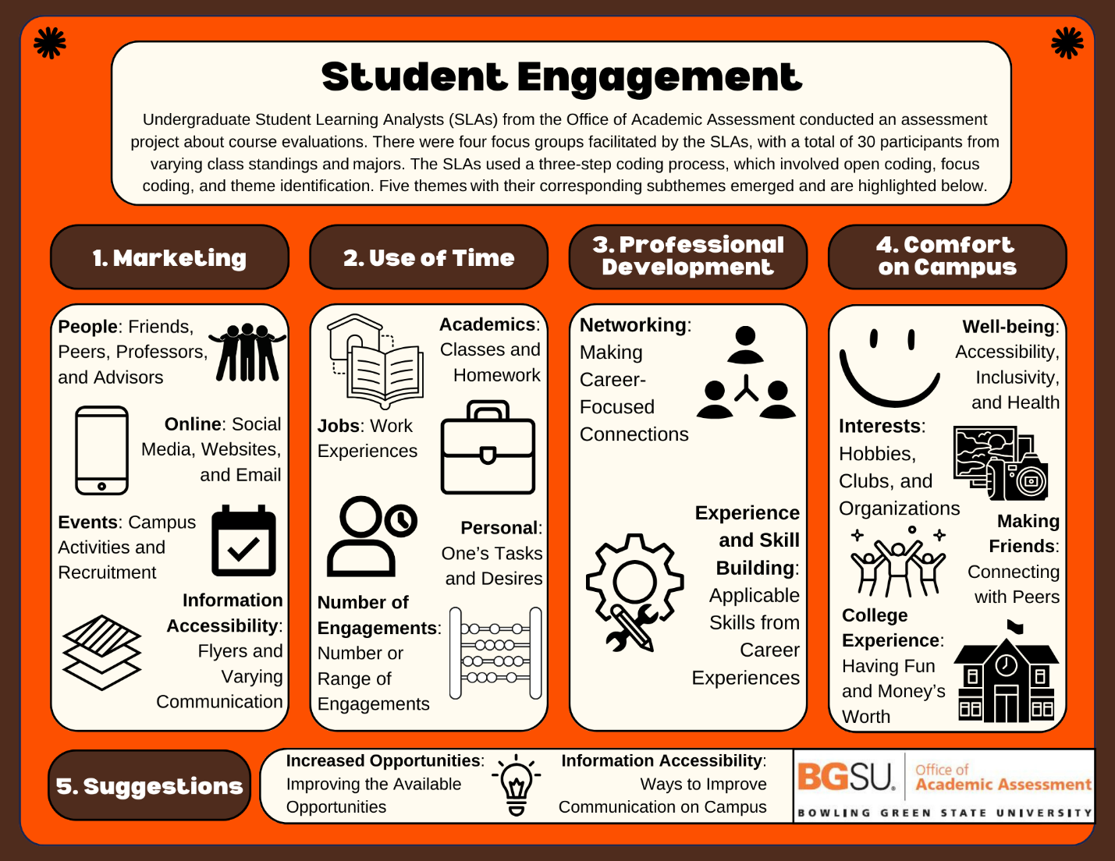

For more information about this assessment project, please contact Dr. Jessica M. Turos, Associate Director of the BGSU Office of Academic Assessment, at jmturos@bgsu.edu.

