Qualtrics Help Information
Qualtrics users seeking support (e.g., live chat, phone call, or email) need to log into the Qualtrics Support Portal following the steps below.
- Log into Qualtrics using the BGSU single sign on link: http://bgsu.qualtrics.com/

- Within Qualtrics, click on the question mark icon:
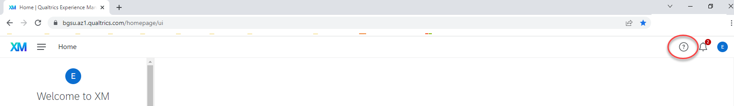
- Click on “Contact Support”

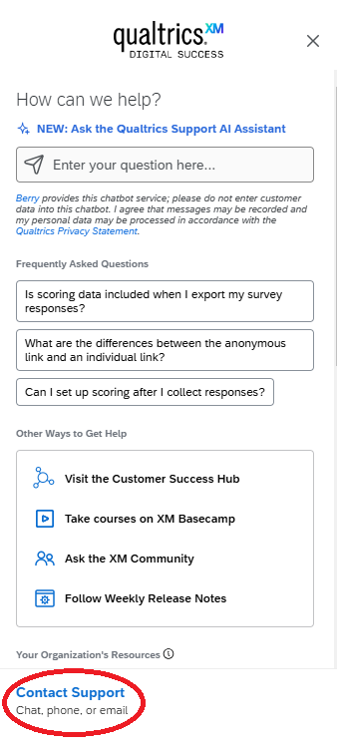

- Click on Bowling Green State University
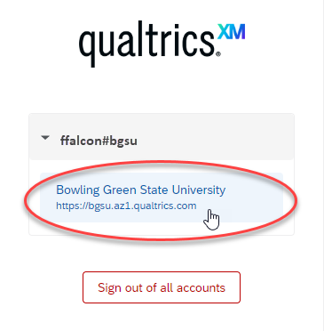

- Select “Survey Platform & XM Directory”.
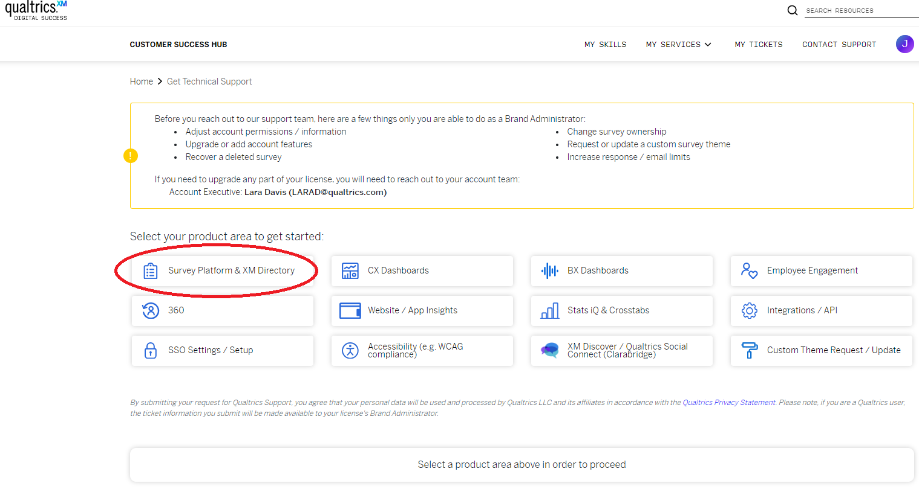

- Once you select “Survey Platform & XM Directory”, the Qualtrics Support AI Assistant will appear. Type your question and the AI assistant will provide information, screenshots, and links.

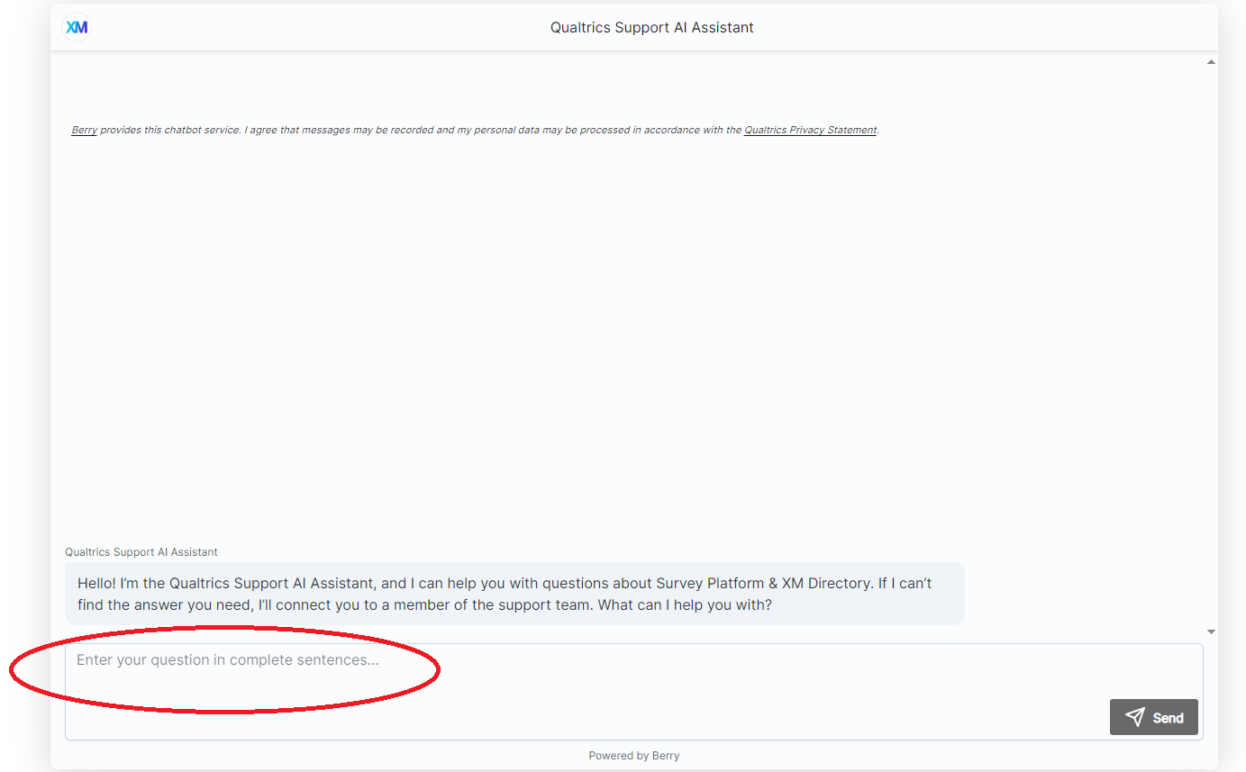

- If the Qualtrics Support AI Assistant cannot answer your question, select “No” when they ask, “Did I answer your question?” You will then be provided with a button for you to select to contact the Qualtrics Support Team.

