Bowling Green State University

University-wide Course Evaluation of Teaching and Learning

Administrator Guide
Prepared by the Office of Academic Assessment

June 2023

University-wide Course Evaluation of Teaching and Learning
Guidelines for Administrators Table of Contents

University-wide Evaluation of Teaching and Learning 4
Common Questions 4
Common Question Scoring 5
Student Anonymity 5
Hierarchical Reporting 5
Course Evaluation Project Creation and Deployment 5
Course, Instructor, and Student Import 6
Departmental Review and Acceptance 6
Evaluation Administration Dates 7
Messaging 7
Course Evaluation Delivery 8
Availability of Evaluation Results 8
Accessing the University-wide Course Evaluation System 8
Accessing Course Evaluation Results via BGSU’s Single Sign on System 8
Accessing Course Evaluations Results through Canvas 8
Canvas Account Settings Method 8
Canvas Course Evaluation Administrators Method 9
Course Evaluations Homepage 11
Manage Courses 11
Response Rate Tracker 12
Course Evaluation Reports & Data 13
Report Formats 13
Detailed Report Format(s) 14
Interpreting Comparison Statistics on the Detailed Report 15
Short Report Format(s) 16
Comparing Department/Unit Results Against College and University Results Using the Detailed and Short Report Formats 18
Raw Data Report 19
Common Question vs. Targeted Question Reporting 19
Means of Means Calculation 20
Accessing Course Evaluation Results 20
Finding Reports Using the By Hierarchy Level 21
Finding Results Using the Course Selection Tab 23
Finding Reports Using the By Instructor Tab 23
Downloading Reports 24
Batch Reports 25
Batch Reporting (Combining Results from Multiple Courses or Instructors into a Single Report or Generating a Zip File with the Separate Reports) 25
Additional Information 27

University-wide Evaluation of Teaching and Learning

Bowling Green State University’s University-wide Evaluation of Teaching and Learning is administered each semester, allowing students to provide meaningful feedback about their courses. BGSU Faculty Senate and Academic Affairs collaborated to develop a set of common University questions on course expectations, feedback and assessment, support for student success, and engagement. The common course evaluation questions were developed by an ad hoc committee, inclusive of faculty, administrators, union, undergraduate and graduate student representation. The questions were piloted in AY2017-2018 and fully implemented in Fall 2018. With its focus on assessment for continuous improvement, the University-wide Evaluation of Teaching and Learning aligns with BGSU’s Strategic Plan Forward, Strategic Objective 1, Initiative 2: Intensive focus on outcomes and Strategic Objective 3, Initiative 10: Teaching and service excellence.

The University-wide Evaluation of Teaching and Learning is composed of six common course evaluation questions which are asked across all courses, followed by optional questions that specific colleges or departments/units have developed in collaboration with the Office of Academic Assessment. The six questions that are included in all course evaluations are referred to as the common questions. Questions developed by individual Colleges or academic units are referred to as targeted questions.

When completing course evaluations, the six common questions are presented to students first, followed by any additional targeted questions used by their college or academic unit (department/unit). When targeted questions have not been assigned, only the common questions are presented. In classes that are taught by two or more instructors, students are presented with drop-down lists which display their instructors’ names. Students can use these drop-down lists to evaluate each instructor separately.

Common Questions
The six common questions provide a focus on continuous improvement and all begin with the statement, “The instructor….” The questions fall under 5 categories, as summarized below:

Category 1: Expectations
- The instructor clearly explains course objectives and requirements.
- The instructor sets high standards for learning.

Category 2: Feedback and Assessment
- The instructor offers helpful and timely feedback throughout the semester.

Category 3: Support for Student Success
- The instructor provides opportunities and/or information to help students succeed (for example, tutoring resources, office hours, mentoring, research projects, etc.).

Category 4: Engagement
- The instructor encourages student participation (for example, by inviting questions, having discussions, asking students to express their opinions, or other activities).

Category 5: Diversity, Inclusion, and Equity
- The instructor creates an environment of respect.

Common Question Scoring
Students are provided the response options presented below.

Response
Strongly Disagree
Disagree
Neither Agree nor Disagree
Agree
Strongly Agree

Student Anonymity
The anonymity of students who respond to the course evaluation is protected to the degree possible. To protect anonymity, starting in Summer 2023, combined courses are cross-listed into their main sections in the evaluation (for example, an honors section of Biology 1010 will be cross-listed in the evaluation software with the main section with which it is taught at the same time by the same instructor and at the same course level, as combined in the CSS system). If departments/units would like those results separated by section, the Office of Academic Assessment can send those results. Also, departments/units are given the opportunity to remove sections with fewer than 5 students enrolled from the evaluation. Finally, course evaluation results are not made available to administrators or faculty until after grades have posted at the end of each semester.

Hierarchical Reporting
Couse evaluation results are reported within a hierarchy of colleges and departments/units. Faculty administrators and office staff have access to results within their corresponding hierarchy level. The Office of Academic Assessment manages access to course evaluation results by creating administrator accounts within the course evaluation system.

Note: When new office staff are hired by academic units, the Office of Academic Assessment can create their account and grant access to their department’s/unit’s data once notified by a Dean, Associate Dean, or Department Chair.

Instructors can access and view course evaluation results for any course in which they are listed as an instructor of record.

Course Evaluation Project Creation and Deployment
A new course evaluation project is created each semester following the conclusion of the 15th day of classes. Project setup includes the following tasks:
- Identifying the instructor (or instructors) of record for each course.
- Generating student rosters by synching the course evaluation data with course rosters from Canvas.
- Ensuring the course hierarchy levels are correct.
- Identifying courses that may need to be excluded from the evaluation project.
- Assigning targeted survey questions to courses.
- Specifying the administration dates during which students will complete course evaluations.
- Defining the date after grades have posted upon which course evaluation results will become available to administrators and instructors.
- Configuring project communications.

Course, Instructor, and Student Import
Courses, assigned instructors, and student rosters are imported into the course evaluation system from Canvas following the 15th day of each term.

- Course Import: courses are imported once (and only once) from Canvas when the evaluation project is created. Following this initial import, courses are manually updated based upon information provided to the Office of Academic Assessment by administrators from the academic offices.

- Instructor Import: as with courses, instructors are imported just once from Canvas during project creation. Instructor assignments are then manually updated based upon information received by the Office of Academic Assessment from the academic offices.

Note: Only instructors of record are assigned to courses. Teaching assistants are not included in the course evaluations. Some college and academic offices chose to evaluate teaching assistants using an evaluation project that is separate from the University-wide evaluation.

- Student Import: rosters of enrolled students are loaded into the course evaluation system following the 15th day of the semester. Student enrollments are refreshed daily from Canvas up until the completion of the evaluation period for each course.

Note: Students are removed from course evaluation lists only after they have formally dropped or withdrawn from the course and the de-enrollment action has been recorded in the Campus Solutions System (CSS) by the Office of Registration and Records and refreshed in Canvas. Students who, for one reason or another, have discontinued attendance of a course, but who have not officially withdrawn or dropped the course, will still receive an evaluation.

Departmental Review and Acceptance
Course and instructor lists are forwarded to each academic department/unit for review and acceptance following the initial import of data from Canvas. During this stage of project deployment, administrators from the college offices have an opportunity to identify changes needed for courses and instructor assignments. Administrators are asked to review a "Department Acceptance Report" and notify the Office of Academic Assessment know if there are courses missing or needing to be removed from their hierarchy. The Office of Academic Assessment implements changes in the evaluation system settings as responses are received from the academic units.

Note: Changes to courses, instructors, and targeted question assignments must be made prior to the start of the evaluation period. Once students begin submitting evaluations for a course, its settings, including the instructor of record and assignment of targeted questions, cannot be modified.

Evaluation Administration Dates
Students are permitted to complete course evaluations only during prescribed time periods that are dependent both upon the semester and the course session. Timelines for the administration of course evaluations occur as follows:

- Fall and Spring Semesters
  - 15-week sessions: 2 weeks prior to the final exam week.
Note: Only the 15-week session has a designated finals week.
  - 11-week sessions: last 2 weeks of the session.
  - 7-week sessions: last week of each session.

- Summer Semesters
  - 6, 8, or 12-week sessions: last week of each session.
  - Sessions shorter than 6 weeks long (3 or 4 weeks) have a condensed evaluation period.

Messaging
Email messages are sent to administrators, instructors, and students’ BGSU email accounts based upon course evaluation administration dates.

- Course Evaluation Announcement: an initial announcement message, which includes the administration dates for all sessions, is sent to all unit administrators prior to the start of course evaluations.

- Upcoming Course Evaluation Email: instructors receive an announcement message approximately 5 days prior to each evaluation start date with a list of their courses for the semester.

Note: All courses are included in this message, including those that may begin during a 2nd or 3rd session that has not yet begun.

Instructors should review this message closely and contact their academic office, or email the Office of Academic Assessment, if they notice any errors in their list of assigned courses. Corrections to instructor assignments must be complete before the administration period begins.

- Course Evaluation Email: students and instructors receive an announcement message on the first day that evaluations become available.

- Non-Respondent Email: non-responding students receive up to 3 reminder messages during the evaluation period.

- Certificate of Completion Email: a certificate of completion is emailed to students following the completion of each course evaluation.

Note: When desired, students may forward their Certificate of Completion email to their instructors as evidence that they have completed an evaluation of their course. The Certificate of Completion does not include information that would identify responses as belonging to an individual respondent.

- Results Notification Email: administrators and instructors receive an email stating that their evaluation results are available. This message is typically sent the day after grades are due.

Course Evaluation Delivery
The University-wide Evaluation of Teaching and Learning is administered online. Students may access their evaluations either by following links in their announcement emails or by logging in through their Canvas accounts. Students receive reminders when course evaluations are available every time they log into Canvas.

Availability of Evaluation Results
At the end of each semester, results are available for faculty administrators, office staff with account access, and instructors to review the day after the Registrar posts final grades in CSS. Results for courses taught during the first term sessions (e.g., 6, 7, or 8-week) are not available until the end of the semester since grades for those courses can be modified until the end of the semester.

Accessing the University-wide Course Evaluation System

Administrators and instructors can log into the course evaluation system to review courses, instructors and survey assignments for active projects, track response rates for active projects, and access results for previous projects.

The system can be accessed directly using BGSU’s single sign on or through Canvas.

Accessing Course Evaluation Results via BGSU’s Single Sign on System
Use the BGSU single sign on link: https://bgsu.evaluationkit.com/ to access Course Evaluations online.

Accessing Course Evaluations Results through Canvas
There are two ways to access Course Evaluation results within Canvas.

Canvas Account Settings Method
To access course evaluation results using your Canvas settings:

- Click on Account, then
- Settings, then
- Course Evaluations.

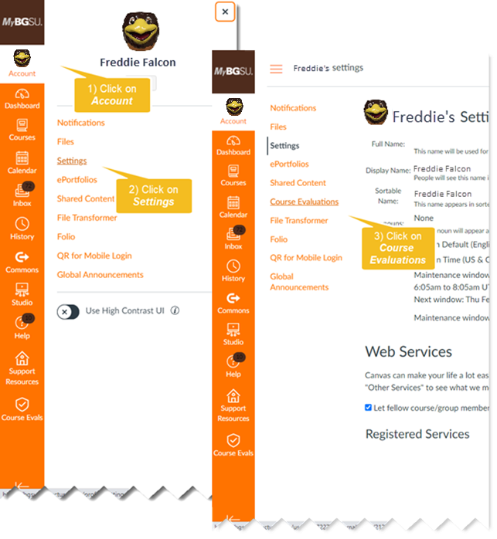

Canvas Course Evaluation Administrators Method
To access results using the Course Evaluation Administrators course in your Canvas dashboard:
- Click on the Course Evaluation Administrators course.
- Click on University-wide Evaluation of Teaching and Learning module.
- Click on University-wide Evaluation of Teaching and Learning assignment.
- Click on the Load in a New Window link.

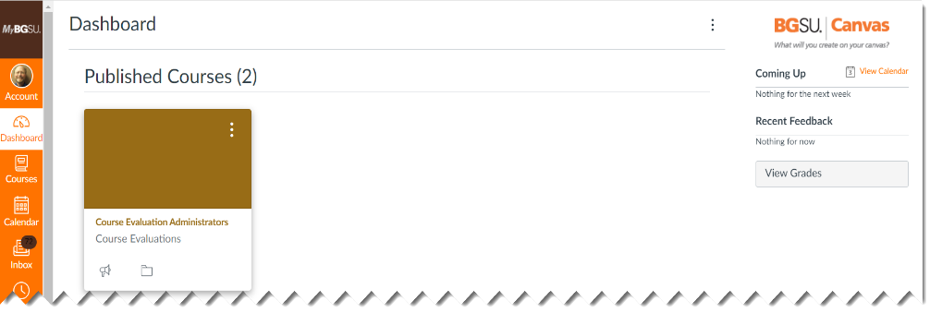
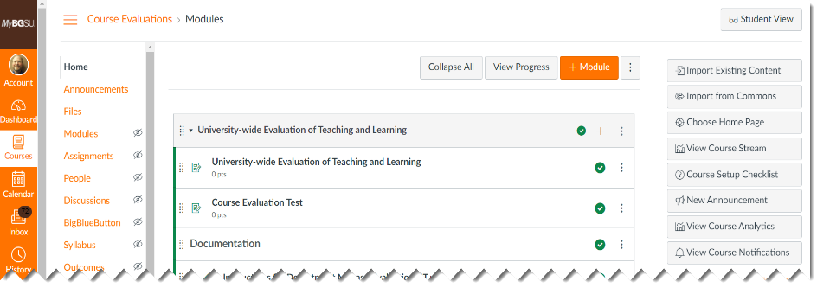


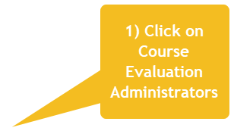
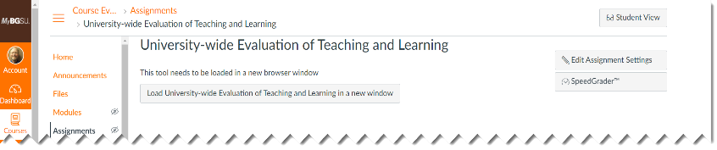


If the Course Evaluation Administrators course is not listed in your Canvas dashboard:
- Click on Courses within Canvas to find it listed there; or
- If Course Evaluation Administrators is not listed within your list of Canvas courses:
  - Scroll to the bottom of the list and click on All Courses.
  - Click on the star in front of Course Evaluation Administrators to add the course to your Canvas Dashboard.
  - If Course Evaluation Administrators does not appear in your list of available courses, contact the Office of Academic Assessment and request to be added as a member of the course.

Note: Upon logging in to the system, the default role is Student. Administrators must use the dropdown in the upper-right corner of the page to change the role to Administrator to access their department’s/unit’s data.

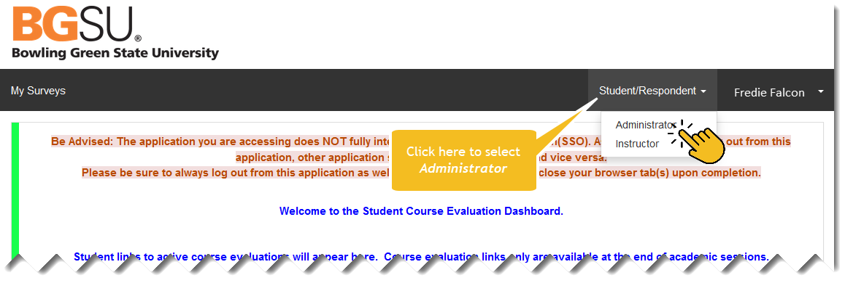

Course Evaluations Homepage

After logging into the system, users are presented with the Course Evaluations Homepage, which displays four features:

- Manage Courses: provides access to lists of the courses included in an active evaluation project, including the names of enrolled students and instructor(s) of record.

- Response Rate Tracker: displays response rate statistics for an active course evaluation project. The statistics shown on the My Surveys home page widget display aggregated response rates for all courses included within administrators’ assigned hierarchies. Following a link to any open project allows administrators to drill down and view response rates at the hierarchy and course levels.

- Project Results: displays links to all closed course evaluation projects where administrators can access evaluation results.

- My Surveys: links to any evaluations assigned to students’ accounts. For administrators who are not attending courses as a student, this link will provide no information. For administrators who are enrolled as students during a term for which an evaluation project is in progress, the link will display courses for which evaluations still need to be completed.

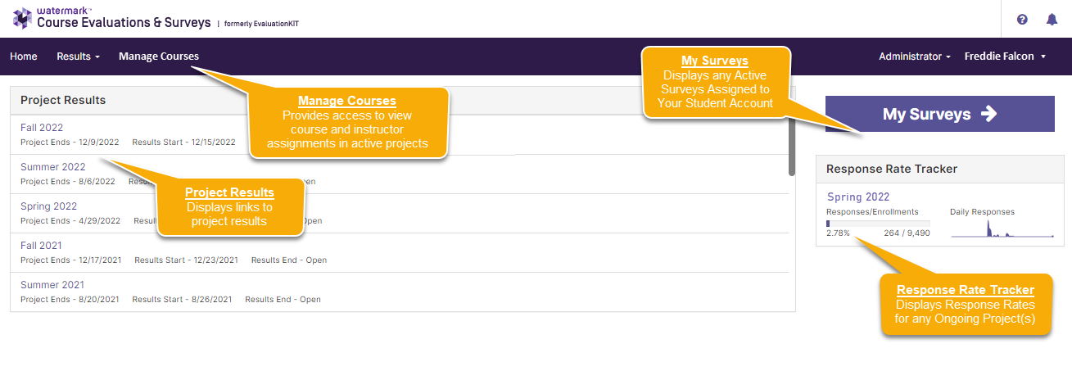

Manage Courses
The Manage Courses feature allows administrators to review the list of courses in an evaluation project, along with their instructor(s) of record and enrolled students. Using this feature, the administrator may also preview the evaluation survey for each course as it will be seen by students.

To access the Manage Courses feature:
- Click on Manage Courses from the Home Page menu.
- Select the active project that you want to review.
- Review the courses and instructors or preview the evaluations in the resulting list of courses.
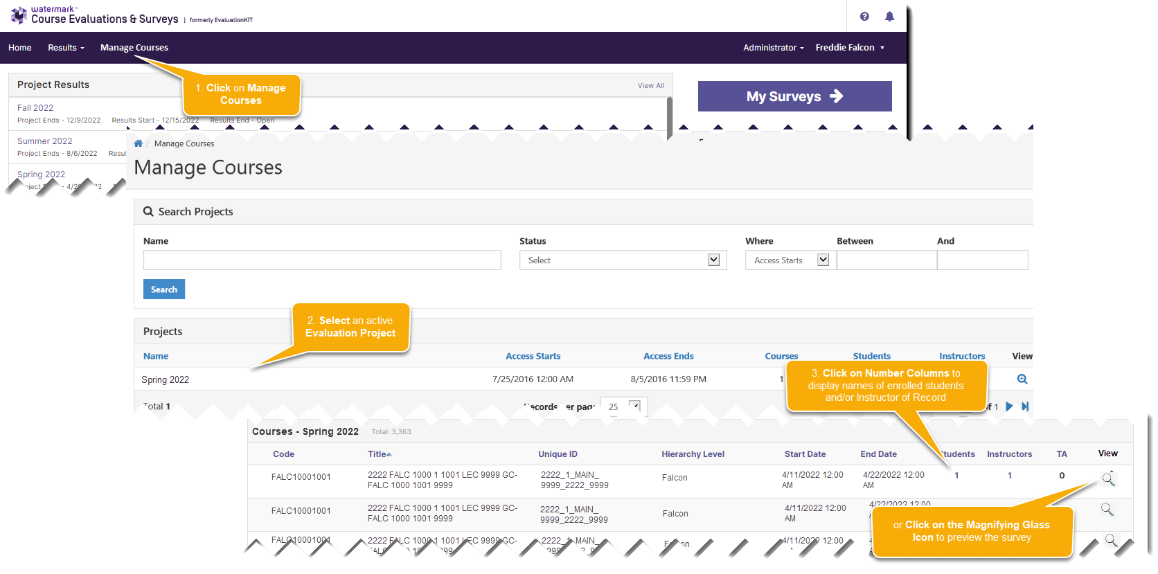

Note: Report any errors observed in courses, instructor assignments, or surveys to the Office of Academic Assessment.

Response Rate Tracker
The Response Rate Tracker allows administrators to view response rates for any courses assigned to their hierarchy and instructors to view response rates for their assigned courses while an evaluation project is in progress.

To access response rate statistics for an open course evaluation project:
- Click on any project shown under the Response Rate Tracker widget on the Home Page (or select Results from the Home Page menu bar and then Response Rate Tracker from the dropdown menu).
- Select a hierarchy level from the Node Response Rates page.
- Review the results for the selected hierarchy on the Course Response Rates page.

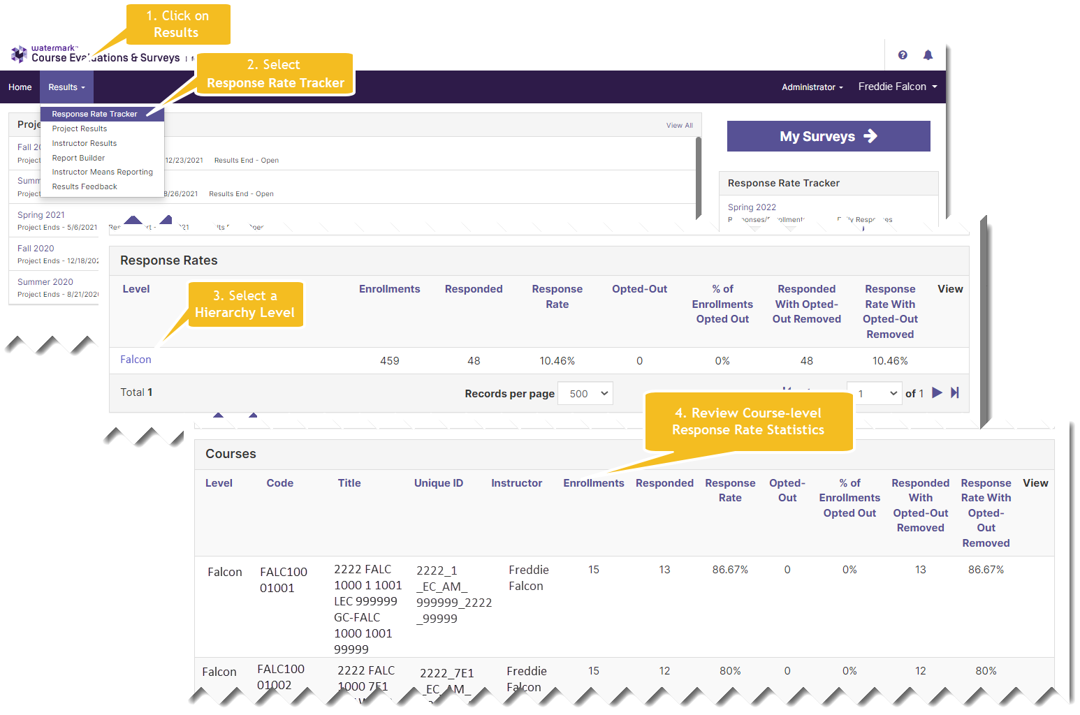

Note: We recommend that administrators and instructors log in and check the Response Rate Tracker regularly while a project is in progress to monitor response rates. Instructors can encourage greater participation from their students if they notice that response rates are low and they can collaborate with their unit to identify key strategies for increasing student engagement with the University-wide Course Evaluation.

Course Evaluation Reports & Data

Report Formats
Five types of report format are available from the course evaluation system:

- Detailed Report - a PDF report which provides summary statistics obtained for each question in the course evaluation, including frequencies, standard deviation, median, and mean scores shown at the course, college, and university levels.

- Detailed Report + Comments – a PDF report which includes student comments in addition to the summative statistics described above.

- Short Report – a PDF report that displays summary statistics, including mean scores for each question in a condensed format at the course, college, and university levels.

- Short Report + Comments - a PDF report that includes student comments in addition to the summative statistics provided in the condensed report described above.

- Raw Data - an Excel data file which includes anonymized results at the individual response level. The raw data file can be used in Microsoft Excel or Power BI to generate reports that go beyond the four packaged reports which are outlined above.

In all reports, results for the six common questions are shown first, followed by any targeted questions the college or department/unit might be using.

Notes:
- The Detailed Report + Comments report is recommended as the default report for both instructors and administrators because it includes student comments in addition to question-level response frequencies and mean scores.

- For colleges and departments/units that use targeted questions that only collect qualitative data (i.e., student comments), the Detailed Report + Comments or Short Report + Comments report must be used to view results. Otherwise, no results will be shown for those questions.

Detailed Report Format(s)
There are two types of Detailed Report formats, both of which may be downloaded from the evaluation system in PDF format:

- Detailed Report: produces a PDF report with quantitative statistics for each evaluation question.

- Detailed Report + Comments: produces a PDF report which includes student comments in addition to all elements of the Detailed Report.

Each format produces a PDF report which includes a header, results, and mean of means section:

- The header section displays the name of the course, identifies the instructor of record, and shows the overall response rate (number of students who participated in the course evaluation divided by the total number of students enrolled in the course).

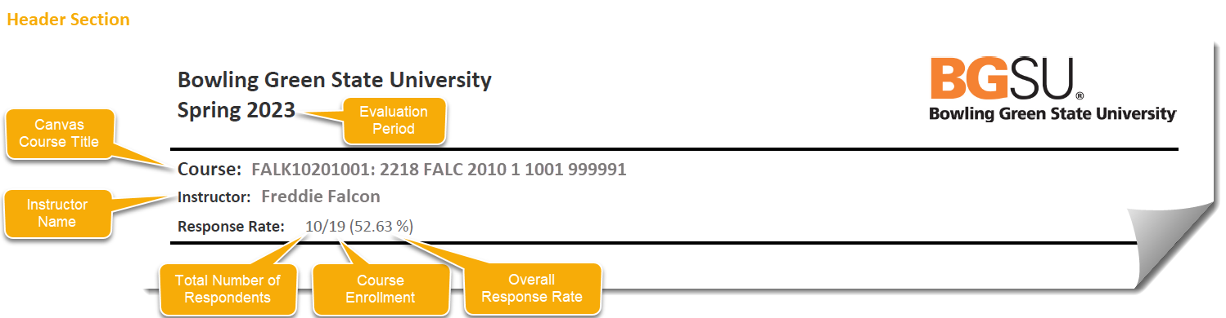

Note: When courses are co-taught, all instructor names appear in the Instructor line and the instructor for whom the report is being generated is indicated by an asterisk.

- The results section summarizes response statistics for each course evaluation question; including the question text, response options, response option frequencies (number of students selecting each response item), question response rate (number of students who completed the question divided by the total number of students in the course), mean score (average), standard deviation (measure of variability), and median (middle). Summary results for each item are displayed side-by-side at the course, university, and college levels. Student comments are included only when the Detailed Report + Comments report has been selected.

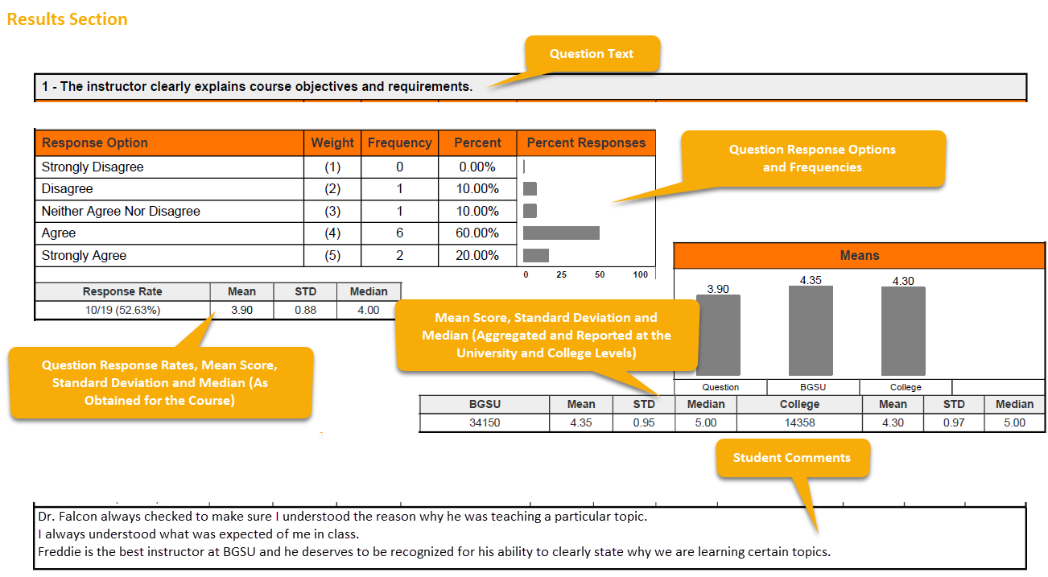

The mean of means section, which is shown at the bottom of the Detailed Report provides a combined mean score for all six common questions.

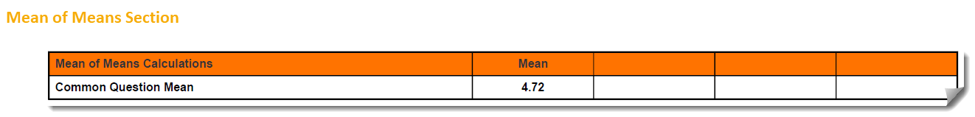

Interpreting Comparison Statistics on the Detailed Report
The Detailed Report can be run at three levels (course, instructor, and hierarchy) and, depending upon which level it is run, the report produces different comparison results in the statistical summaries.
- Course-level Reports: when run at the course level, the Detailed Report compares averages for each question, including any targeted questions, at the course level, the university level, and the college level:
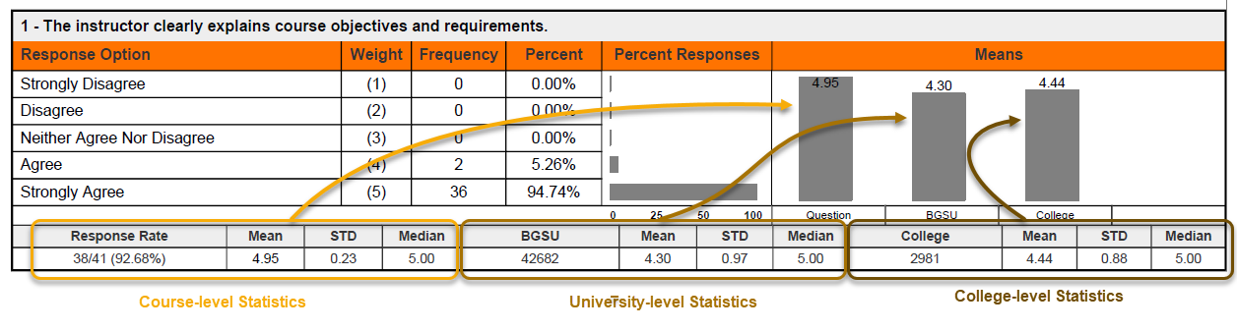
- Instructor-level Reports: when run at the instructor level, the Detailed Report displays average scores, standard deviations, and median scores for each question, including any targeted questions, with data aggregated for all courses taught by the instructor, side-by-side with university and college level comparisons:
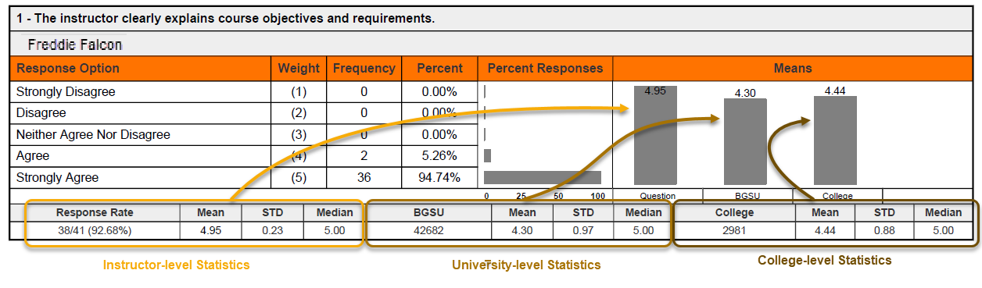
Hierarchy-level Reports: when run at the hierarchy level, the Detailed Report displays aggregated averages from every course within the hierarchy structure for each question, including any targeted questions, at the hierarchy level only:
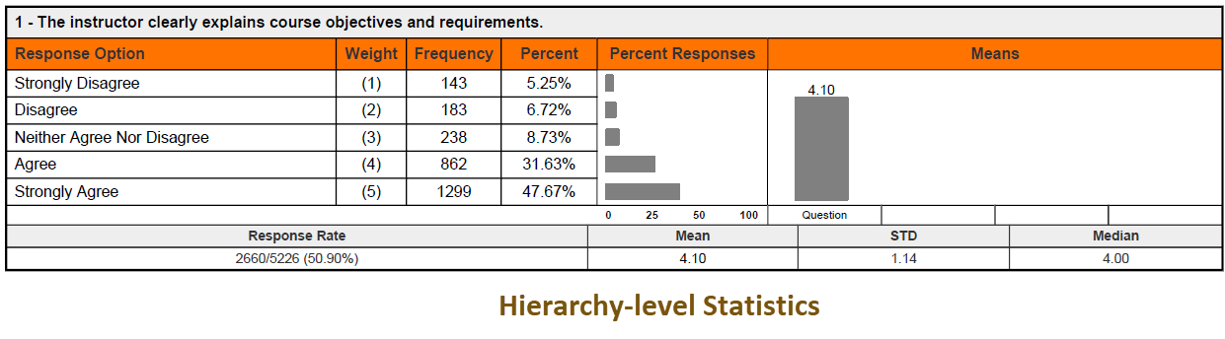

Short Report Format(s)
As with the Detailed Report, there are two types of Short Report formats:

- Short Report: produces a PDF report with condensed quantitative statistics.

- Short Report + Comments: produces a PDF report which includes student comments in addition to all elements of the Short Report.

When run at the course level, the header section of the Short Report identifies the name of the course, instructor of record, and response rate. The results section of the report presents results for each question in a linear fashion with response frequencies first, followed by mean scores obtained at the university and college levels, and then the mean, standard deviation, and median score obtained at the course level.

When run at the instructor levels, the header section of the Short Report identifies the instructor of record and response rate. The results section presents aggregated results for all courses taught by the instructor for each question in a linear fashion. Response frequencies are presented first, followed by mean scores obtained at the university and college levels, and then the mean, standard deviation, and median scores for each question.

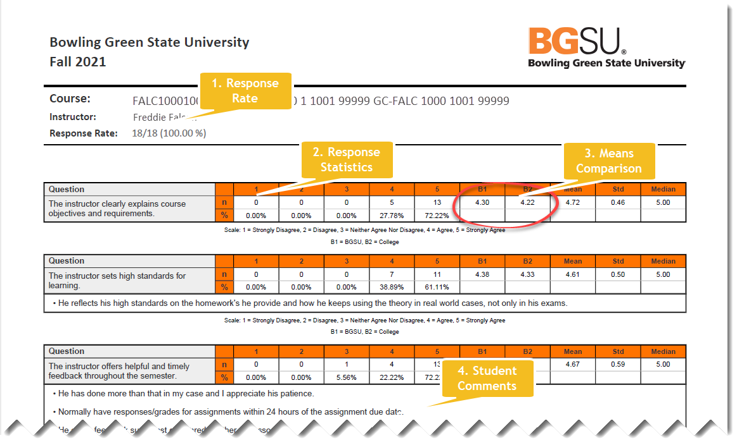

When run at the hierarchy level, the report only shows departmental/unit results and excludes the university and college level comparisons:

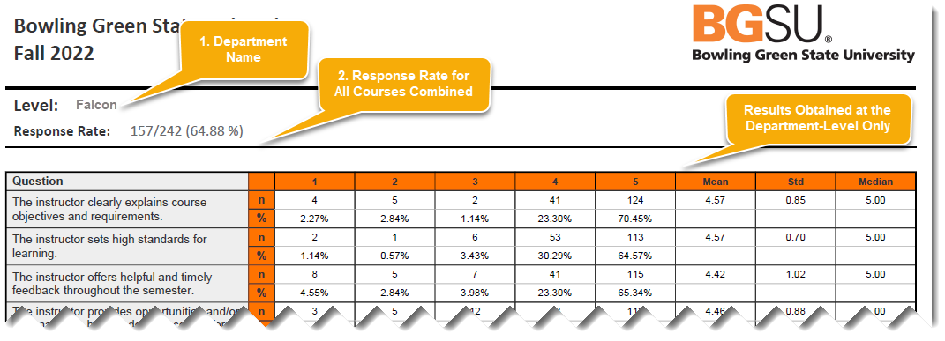

Comparing Department/Unit Results Against College and University Results Using the Detailed and Short Report Formats
Hierarchy-level reports combine the results of all courses within the selected hierarchy into a single report.
Departments/Units may compare their averages to college or university averages by combining the results obtained by generating Detailed Reports at their own Hierarchy level with results generated at either the Course or Instructor level:
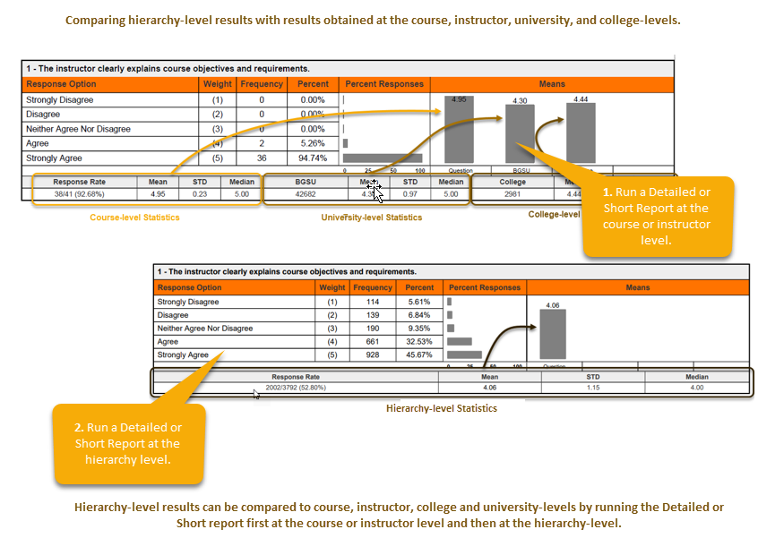
Notes:
- There is no report that combines results for the hierarchy (other than the college level) with course/instructor, college, and university levels all in one view.
- The hierarchy-level Detailed and Short Reports are the only report formats that display departmental/unit averages at the item level. All other reports compare means at the college and university level.
- To compare hierarchy level results with the instructor, course, college, and university levels, the Detailed or Short Report must be run twice. Once at the course or instructor level, and again at the hierarchy level.

Raw Data Report
Raw data output is available for each course or selection of courses using the Raw Data Report. When this report format is selected, the course evaluation system produces an Excel file with anonymized evaluation data. Each row in the raw data file represents responses submitted by an individual student for a single course. Data elements provided in the Excel file include:

- Course information: hierarchy, course code, course title, unique course id, number of instructors, and total enrollment.

- Instructor information: instructor username, Canvas ID number, and name.

- Response data: number of respondents and response rate.

- Evaluation data: question-level responses including quantitative ratings and student comments.

The raw data file is useful for running further analysis to identify trends and areas for growth. However, in classes that are co-taught the numbers for enrollments and respondents are duplicated when students evaluate both instructors, as results for the evaluation of both instructors are reported in separate rows using the same figures for enrollment and response rate. Therefore, when creating averages using the Raw Data report in Excel or another program for co-taught courses each student should be counted once to obtain the correct response rate (even if they evaluated more than one instructor) and sums of student enrollments should only be counted once per course to obtain the correct enrollment count.

Hierarchy-level means: when run at the hierarchy level, the Raw Data Report, exports all evaluation results (except for personally identifying information) for each class within the hierarchy. This allows departments/units to create their own reports using data obtained from the evaluation for all classes which were evaluated within the department’s/unit’s position in hierarchy.

Common Question vs. Targeted Question Reporting
In all report formats, the six university-wide common questions are presented first. Any targeted questions utilized by a college or department/unit follow beneath the common questions.
Note about interpreting common question vs. targeted question comparisons: since the common questions are included in all course evaluations, the comparisons shown on the Detailed and Short Reports for the instructor, university, and college all differ according to the responses submitted by students. However, since targeted questions apply only to colleges or departments/units, results are repeated at the university and college levels in these reports since targeted questions are not evaluated at the university level.

Means of Means Calculation
A means of means calculation is provided at the end of the Detailed and Short Report formats to show the combined mean score obtained on the evaluation for all six common questions.

Note: While it appears at the end of the Detailed and Short Report formats, the Mean of Means calculation only averages the 6 university-wide common questions. It does not include results from any targeted questions that may be used by the college or department/unit.

Accessing Course Evaluation Results
To view course evaluation results, after logging into the course evaluation system:

1. Click on Results.
2. Project Results.
3. Select a semester evaluation project to access the course evaluation data.

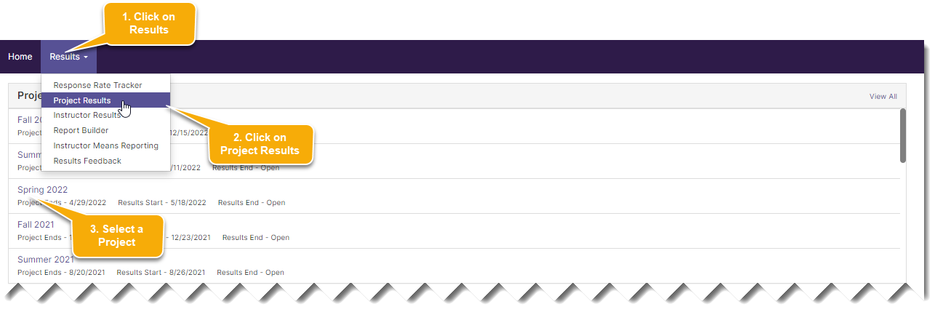

There are three methods administrators may to search for results, and each method has a tab on the Project Results search page:

- By Hierarchy Level allows administrators to search for and access results for an entire college or department/unit by selecting an item from the hierarchy map.

- Course Section allows administrators to find results by searching for a specific course or group of courses using a combination of course code patterns, Canvas course titles, and hierarchy levels. Courses may be reported individually or batched together in various ways to combine results from more than one course.

- By Instructor allows administrators to view results for courses taught by an individual instructor by searching for their name. As with the Course Section tab, reports can be run for single courses or batched together to create summary reports.

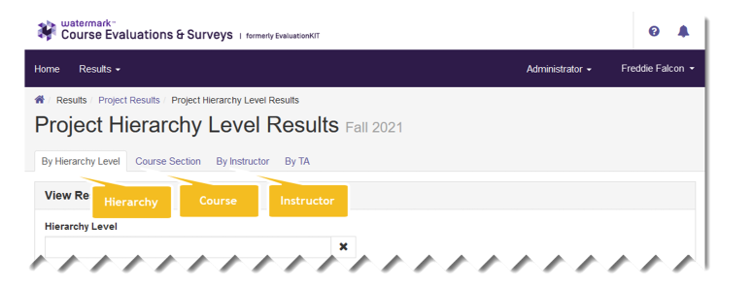

Note: The By TA tab is shown in the View Results page. However, for BGSU’s course evaluation projects, results are only obtained for instructors of record and no results are available on the By TA tab.

Finding Reports Using the By Hierarchy Level
Hierarchy-level reports coalesce all evaluation data obtained at the university, college or department/unit level into a single report.

To search for results using the By Hierarchy Level tab, after selecting a project:

- Click on the By Hierarchy Level tab on the Project Results search page.
- Click into the Hierarchy Level field.
- Select a Hierarchy Level from the list shown.
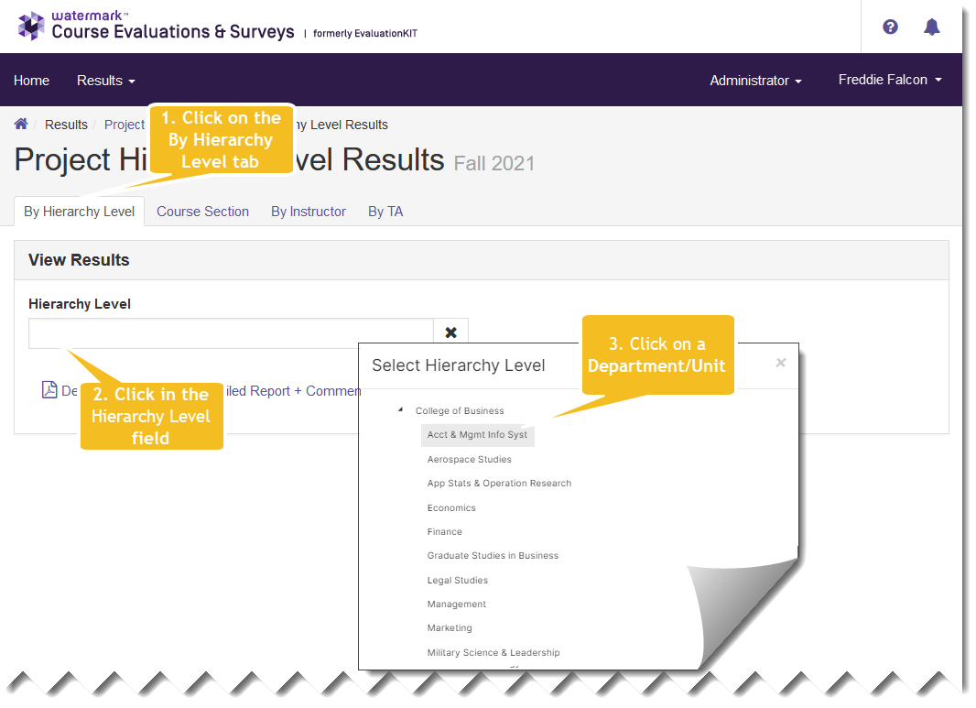

- Generate reports by clicking on one of the report types shown beneath the hierarchy:
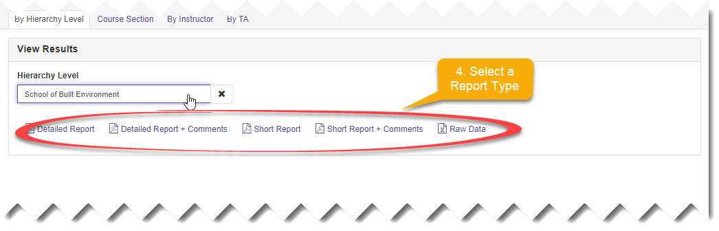
Notes:
- Department/unit hierarchy mappings are the same as those found in Canvas, unless courses have been reassigned to alternate hierarchy levels in the project setup.
- Access to hierarchy levels is assigned to administrators in their course evaluation system account settings and only those levels to which their accounts have been linked will be shown in an administrator’s hierarchy map.
- If an administrator requires access to a hierarchy level that is not displayed in their hierarchy map, or has access to levels that they do not oversee, their Dean, Associate Dean, or Department Chair should contact the Office of Academic Assessment and request that the administrator’s account settings be modified.

Finding Results Using the Course Selection Tab
The Course Section Tab on the Project Results page provides a way for administrators to search for evaluation results obtained for specific courses, or groups of courses.

To find evaluation results using the Course Section Tab:
- Click on the Course Section tab.
- Enter search parameters into the Code, Title, Unique ID or Hierarchy Level fields, or any combination of the four.
- Click the Search button.

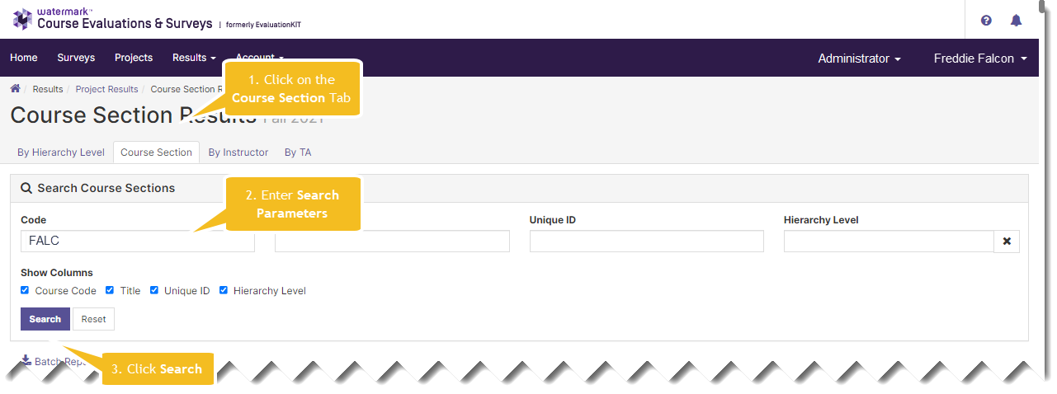

Notes:
- The Code, Title, and Unique ID fields correspond with those found in Canvas.
- Enter partial text into any of the search fields to return courses that contain that text anywhere within the data.
- Examples of searches might include the following elements: Subject, Subject and Catalog Number, Course Number, Session Code, Hierarchy Level, or Campus

- To view results for a single course, click the View button in the rightmost column.
- Then select a report format from the dropdown:

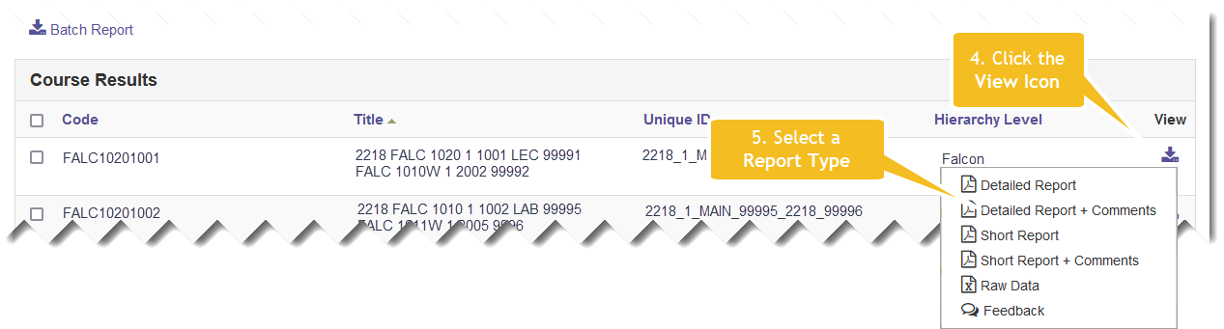

Finding Reports Using the By Instructor Tab
The By Instructor Tab provides a way to find courses, or groups of courses, by searching for instructor names and hierarchy levels.

To search for courses by instructor name:
- Enter an instructor’s name (or partial spelling of a name) into the Instructor Name field. You also can select a hierarchy level, but this is not required.
- Click the search button.
- Produce individual course results by clicking the View Icon and select a Report Format from the resulting dropdown list:
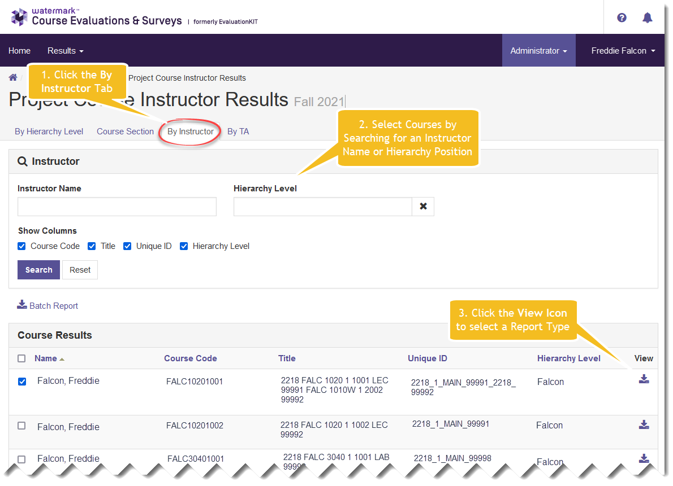

Results from multiple courses can be combined using the Batch Report feature which is described in subsequent sections.

Downloading Reports
Reports are downloaded by selecting a Report Format from the Project Results page after finding the desired courses or instructors.

Regardless of the search method used to find evaluation results, the course evaluation system provides the same set of reports on each of the Project Results page tabs.

Note: Depending upon the size of the data file requested, the course evaluation system may display a message indicating that an email with a link to the report will be sent to your BGSU email account. When this occurs, follow the link in the email when it arrives to download the report.

Batch Reports
The Batch Reporting feature can be used to download multiple reports simultaneously or to combine data from more than one course into a single report.

Batch reporting is useful in the following scenarios:

- An administrator or instructor wants to efficiently generate results for multiple course sections or instructors all at the same time.
- An instructor wants to combine the results for all sections of a course that they taught into a single report.
- An administrator wants to combine results for all sections taught by an instructor, or group of instructors, into a single report.
- An administrator needs to combine the results for all sections of a course (i.e., CHEM 1020) into a single report.

Batch reports can be generated using the Course Section and By Instructor tab of the Project Results page.

Batch Reporting (Combining Results from Multiple Courses or Instructors into a Single Report or Generating a Zip File with the Separate Reports)
To combine results, first select the courses or instructors from which data are required, and then select a batch report type.

To use the batch report feature, search for courses on the Course Section or By Instructor tabs and then:
- Select courses to be included in the report by checking the box next to their name.
- Click the Batch Report link.
- Give the report a Report Name.
- Select a report type.
- Select a delivery type.
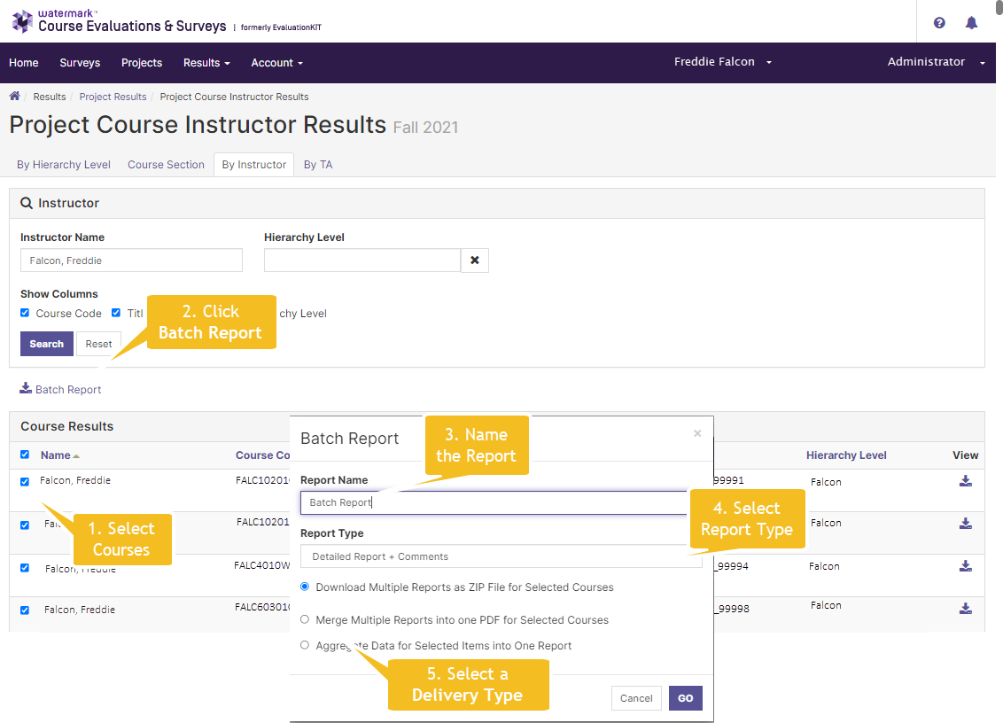

The report types available for batch reports include Detailed Report, Detailed Report + Comments, Short Report, Short Report + Comments, and Raw Data.
Three delivery types are available:

- Zip File: Separate PDF reports will be produced for each of the selected courses and saved into a .zip file.

- Merged Report: Separate reports will be created for each of the selected courses or instructors and combined one after the other to form a continuous, multi-page PDF file.

- Aggregate Report: A single summary report will be created by combining data from each of the selected courses or instructors to form a composite. This option will combine the data obtained from each of the course evaluation questions to create aggregated frequencies, percentages, means, standard deviations, and medians. This report also will provide the means, standard deviations, and medians for BGSU overall and the College for each of the six University-wide questions.

Note: When batch files are requested, the course evaluation system generates an email which provides a link to the results.

Additional Information
Additional information may be obtained by contacting Bowling Green State University’s Office of Academic Assessment at 419-372-5530 or assessment@bgsu.edu.

