Guide for Submitting BGP Assessment Data via Canvas

BGP domain learning outcome assessment data are submitted via Canvas. This guide provides the steps needed to submit your data. Once you have completed the rubric for each student, you have completed your BGP assessment data submission process. Please note, if a student does not complete the BGP Assessment, leave the rubric for that student blank.

Steps for Submitting BGP Domain Learning Outcome (LO) Assessment Data

Go to the assignment that is for the BGP assessment.

Click on SpeedGrader.
*The assignment must be published for SpeedGrader to be accessible.
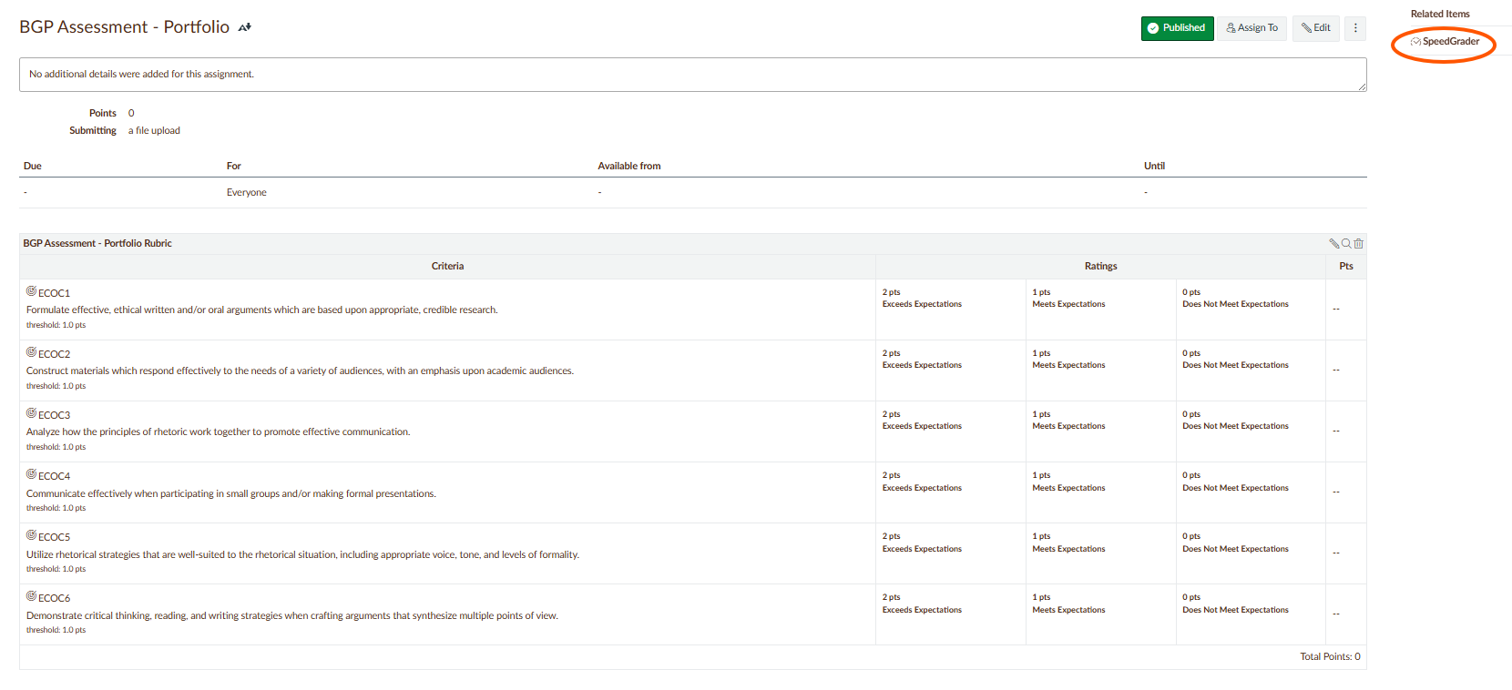

Click on “View Rubric.”
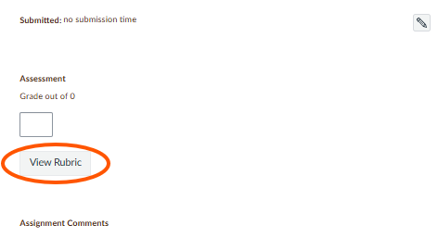

Select the corresponding domain LO ratings (i.e., exceeds expectations, meets expectations, does not meet expectations).
*When you select a rating for a LO, the box will show dark green for exceeds, light green for meets, and red for does not meet expectations. If a student did not complete the assessment, please leave all domain LO ratings blank.
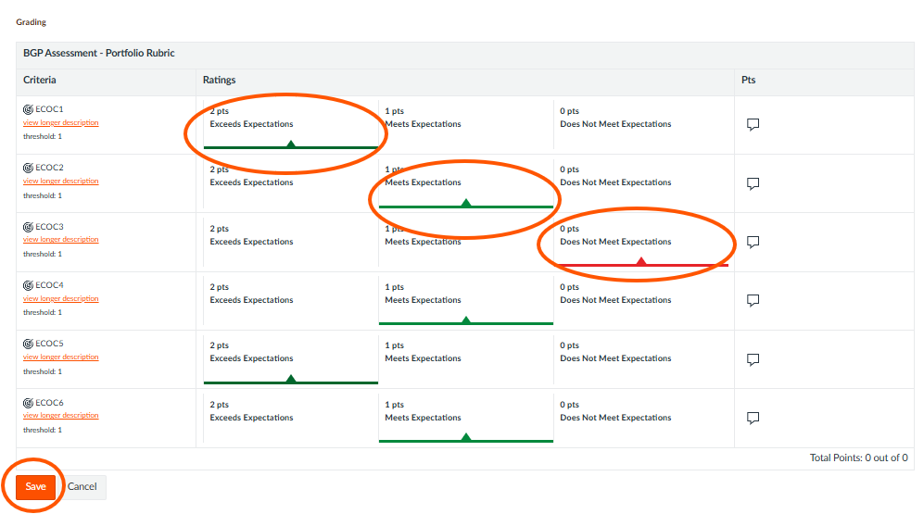

Click on the “Save” button. After you click on the “Save” button, the selected ratings will be the only ratings visible.

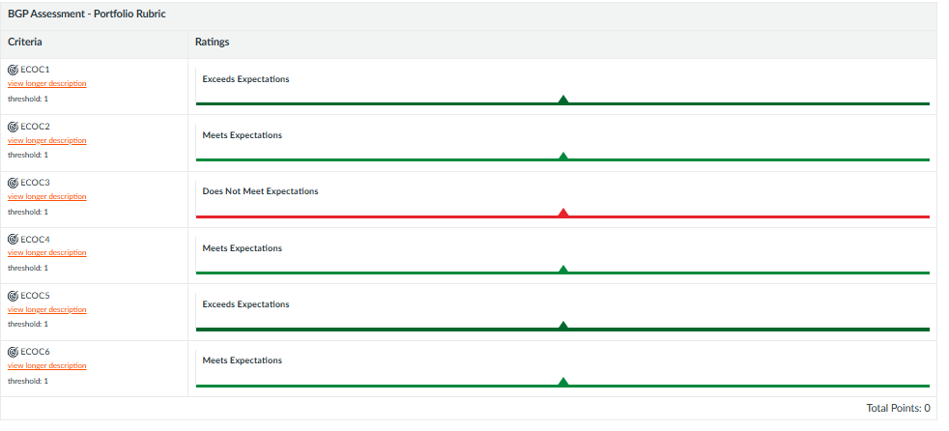

Click on the arrow after the student’s name at the top of the page.
*By selecting the ratings, clicking on “Save,” and clicking on the arrow after the student’s name, you are submitting the BGP domain LO assessment data. You do not need to click on “Submit” in the rubric, that is for the comments box.

Please contact the Office of Academic Assessment at assessment@bgsu.edu if you have any questions.

