SAMPLE MATH PLACEMENT TEST C

Math Placement Test C is for students who have completed a semester of Analytic Geometry, Precalculus, Analysis, Trigonometry, or Calculus. Math Placement Test C is the only placement test which can place you into Calculus I (MATH 1310, 1310H, or 1340). It can result in a recommendation from MATH 1220 through 1310H.

The questions on this sample test are similar to the questions on Test C in format and level of difficulty. However, not all of the topics or types of questions that are on Test C are included here.

The Topics on Test C can be classified into two types, Calculus Readiness and Trigonometry. There are a total of 35 multiple-choice mathematics questions contained in Test C. Approximately two-thirds of the questions relate to Calculus Readiness and the other third are on Trigonometry.

Calculus Readiness questions focus on: Geometry and measurement, graphs of functions, word problems and modeling, concept formation, numerical awareness, exponential functions, exponents and logarithms, equations and factoring, functional notation, inequalities, absolute value, basic trigonometry.

Trigonometry questions focus on: Definition of trigonometric functions, right angles, evaluation of special angles, related angles, radian measure, graphing identities, Laws of Sines and Cosines, trigonometric equations, arc functions, distance, straight line, conics, functions (notation, composition), graphs and their properties, logarithmic and exponential functions, higher degree polynomials, absolute value, inequalities.

- Definition: A function is increasing on the interval $\left[a,b\right]$ if and only if $f\left(x_{1}\right)<f\left(x_{2}\right)$ whenever $x_{1}<x_{2}$, where $x_{1}$ and $x_{2}$ are any number in $\left[a,b\right]$.
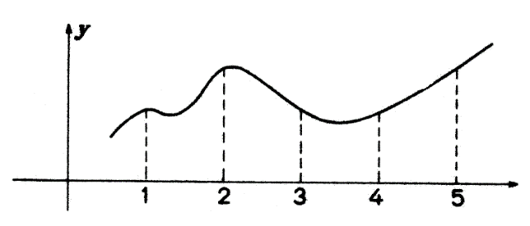
The function $f$, pictured in the graph on the right, is increasing on the interval

(A) $\left[1,2\right]$ (B) $\left[2,3\right]$

(C) $\left[3,4\right]$ (D) $\left[4,5\right]$ (E) none of these

- Given a rectangle with sides of length $x$ and width $y$. Suppose the length $x$ is doubled and the width halved. The new perimeter is

(A) $4x+y$ (B) $\left(2x\right)\left(\frac{y}{2}\right)$ (C) $2x+\frac{y}{2}$ (D) $x^{2}+y$ (E) $x^{2}+\frac{y}{2}$

- Which of the curves best resembles the graph of $f\left(x\right)=\frac{\left(x-2\right)\left(x+3\right)}{\left(x+3\right)}$

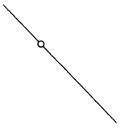
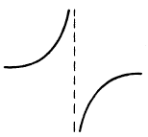
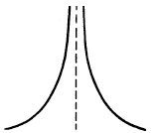
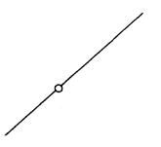
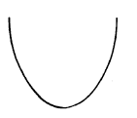
(A) (B) (C) (D) (E)

- If $F\left(x-2\right)=\frac{x+3}{x-4}$, then $F\left(5\right)=$

(A) $-6$ (B) $\frac{10}{3}$ (C) $5$ (D) $\frac{23}{4}$ (E) $8$

- If $\log_{2}{16}=8⋅2^{-x}$, then $x=$

(A) $-7$ (B) $-\frac{4}{3}$ (C) $-1$ (D) $–\frac{2}{3}$ (E) $1$

- The graph representing $\left|x-4\right|≥2$ is

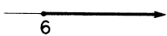
(A) (B) (C) (D) (E)
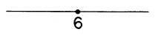
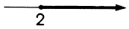
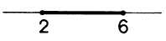

- Which of these choices best describes the alteration made to the graph of the sine curve, $f\left(x\right)=\sin{x}$, for $-π≤x≤π$ ?

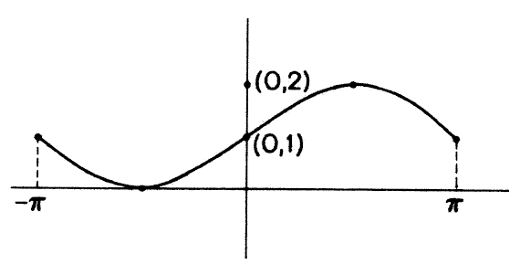
- The amplitude of the graph was doubled.

- The graph was shifted to the left $π$ units.

- The period of the graph was decreased $π$ units.

- The graph was reflected about the $x$-axis.

- The graph was shifted up $1$ unit.

- $\sin\left(\frac{3π}{4}\right)=$

(A) $-\frac{1}{\sqrt{2}}$ (B) $–\frac{1}{2}$ (C) $\frac{1}{2}$ (D) $\frac{1}{\sqrt{2}}$ (E) $\frac{\sqrt{3}}{2}$

- Triangle ABC at the right is an equilateral triangle.

The height $h$ of the triangle is
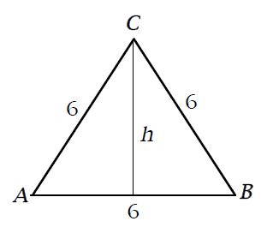
- $3$

- $3\sqrt{3}$

- $6\sqrt{3}$

- $3\sqrt{2}$

- $6\sqrt{2}$

- When $\frac{π}{2}<θ<\frac{3 π}{4}$, which of the following could be the value of $\tan{θ}$ ?

(A) $-8$ (B) $-\frac{1}{8}$ (C) $0$ (D) $\frac{1}{8}$ (E) $8$

- For all real numbers $x$, $\cos^{2}{x}-\sin^{2}{x}=$

(A) $0$ (B) $1$ (C) $\sin\left(2x\right)$ (D) $\cos\left(2x\right)$ (E) $\cos\left(\frac{x}{2}\right)$

- If $f\left(x\right)={10}^{\left(\frac{1+x}{1-x}\right)}$, then $f\left(3\right)=$

(A) $-100$ (B) $–\frac{1}{100}$ (C) $\frac{1}{100}$ (D) $100$ (E) $1000$

- Some values of the functions $f$ and $g$ are given in the table at the right.

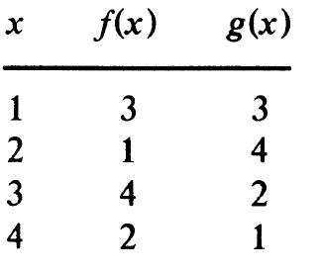
The value of $g(f\left(3\right))$ is

- $1$

- $2$

- $3$

- $4$

- Insufficient information is given.

- An equation for the straight line which passes through the points $(3,2)$ and $(5,-2)$ is

(A) $y=2x+8$ (B) $y=-2x+8$ (C) $y=2x+4$ (D) $y=-2x+4$ (E) $y=-2x-4$

Answers: 1(D), 2(A), 3(B), 4(B), 5(E), 6(C), 7(E), 8(D), 9(B), 10(A), 11(D), 12(C), 13(A), 14(B).

