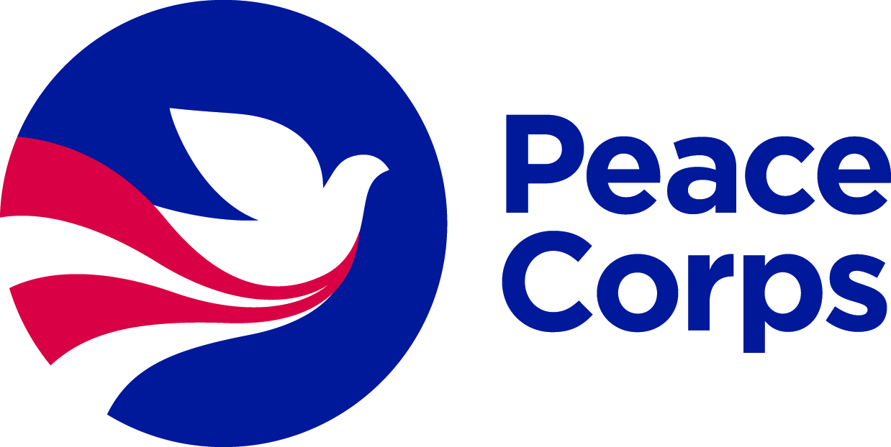


Peace Corps Prep Student Guide

The Peace Corps Prep program will prepare you for international development fieldwork and potential Peace Corps service. To accomplish this, you’ll build four core competencies through interrelated coursework, hands-on experience, and professional development support. These four competencies are the following:

      - Training and experience in a work sector
      - Foreign language skills
      - Intercultural competence
      - Professional and leadership development

This document explains each of these requirements in detail. Use this guide to map out your Peace Corps Prep course of study. In particular, refer to this when completing your PC Prep application, where you’ll need to document how you plan to fulfill each requirement. This guide aligns point-by-point with each section of the application!

            - Training and experience in a specific work sector
3 courses + 50 hours related experience

Leveraging concrete knowledge and skills is central to on-the-ground international development work. Through this PC Prep program, you will begin to build a professional specialty, which should serve your career well whether or not you become a Peace Corps Volunteer.

For PC Prep, you need to complete at least 3 courses that align with a specific work sector (they can but do not need to come from your academic major or minor). You also must accumulate a minimum of 50 hours of volunteer or work experience in that same sector, preferably in a teaching or outreach capacity.

If you intend to apply to the Peace Corps, the best way to assure that you will be a strong candidate is to explore Peace Corps’ openings and identify the type of assignments in which you’d like to serve (www.peacecorps.gov/volunteer/volunteer-openings), then review the positions’ required and desired qualifications and build them up accordingly. In the process, you should fulfill these PC Prep experiential requirements!

Peace Corps
Tip!

There are six sectors (www.peacecorps.gov/volunteer/what-volunteers-do/) in which Peace Corps Volunteers serve—detailed below. Choose one sector to focus on then complete at least 3 courses + 50 hours of related experience in that sector.
Note: Actual Peace Corps assignments are based on local needs, and thus may or may not align seamlessly with your qualifications. Flexibility is central to the Peace Corps experience!
1. Education


Teach lessons that last a lifetime. Education is the Peace Corp’s largest program area. Volunteers play an important role in creating links among schools, parents, and communities by working in elementary, secondary, and postsecondary schools as math, science, conversational English, and resource teachers or as early grade reading and literacy teacher trainers. Volunteers also develop libraries and technology resource centers.

If you choose Education, take 3 courses from one of the following areas:
  - Elementary, Secondary or Special Education
  - English or Linguistics
  - TEFL/TESL
  - Math
  - Computer Science
  - Engineering
  - Any Physical or Biological Science

And build 50 hours of related field experience through an activity such as:
- Teaching in a classroom, with a community outreach organization, or in a formal tutoring capacity
  - The subject you teach may be English as a Foreign/Second Language, special education, drama, STEM subjects, or anything else relating to primary/secondary education

2. Health


Serve on the front lines of global health. Health Volunteers work within their communities to promote important topics such as nutrition, maternal and child health, basic hygiene, and water sanitation. Volunteers also work in HIV/AIDS education and prevention programs to train youth as peer educators, develop appropriate education strategies, provide support to children orphaned by the pandemic, and create programs that provide emotional and financial support to families and communities affected by the disease.

If you choose Health, take three courses from one of the following areas:
  - Nursing
  - Nutrition or Dietetics
  - Health Education
  - Pre-med
  - Biology
  - Technical Education
  - Environmental or Sanitary Engineering

And build 50 hours of related field experience through an activity such as:
- Volunteer or work experience in such areas as HIV/AIDS outreach, hospice, family planning counseling, emergency medical technician (EMT) or CPR teaching/certification, maternal health, and hands-on caregiving in a hospital, clinic, or lab technician setting
- Counseling or teaching in health subjects
- Working as a resident advisor in a dormitory, as a peer nutritionist, or as a sexually transmitted infections counselor
- Significant experience in mechanical repairs, construction, carpentry, masonry, plumbing, hydrology, or set design

3. Environment


Help forge a global movement to protect our planet. Volunteers lead grassroots efforts in their communities to protect the environment and strengthen understanding of environmental issues. They teach environmental awareness in elementary and secondary schools and to youth groups and community organizations, empowering communities to make their own decisions about how to protect and conserve the local environment. Volunteers also address environmental degradation by promoting sustainable use of natural resources.

If you choose Environment, take three courses from one of the following areas:
  - Environmental Science or related field
  - Natural Resources Conservation
  - Park Administration
  - Wildlife Biology
  - Natural Resources or Wildlife Management
  - Forestry
  - Biology, Botany, or Ecology
  - Geology

And build 50 hours of related field experience through an activity such as:
- Educating the public on environmental or conservation issues, or working on environmental campaigns
- Conducting biological surveys of plants or animals
- Gardening, farming, nursery management, organic or low-input vegetable production, or landscaping
- Providing technical assistance and training in natural resource management

4. Agriculture


Lead grassroots efforts to fight hunger in a changing world. Agricultural Volunteers work with small-scale farmers and families to increase food security and production and adapt to climate change while promoting environmental conservation practices. They introduce farmers to techniques that prevent soil erosion, reduce the use of harmful pesticides, and replenish the soil. They work alongside farmers on integrated projects that often combine vegetable gardening, livestock management, agroforestry, and nutrition education.

If you choose Agriculture, take three courses from one of the following areas:
  - Agronomy
  - Horticulture
  - Botany
  - Entomology
  - Agricultural Science
  - Agribusiness
  - Agricultural Economics
  - Business or economics
  - Biology

And build 50 hours of related field experience through an activity such as:
- Working with a large-scale or family-run business involving vegetable gardening, farming, nursery work, tree planting or care, urban forestry, landscaping, livestock care and management, or fish cultivation and production
- Teaching or tutoring the public in environmental or agricultural issues/activities
- Working on the business management or marketing side of a commercial farm

5. Youth in Development

Empower the next generation of changemakers. Volunteers work with youth in communities on projects that promote engagement and active citizenship, including gender awareness, employability, health and HIV/AIDS education, environmental awareness, sporting programs, and info technology.

If you choose Youth in Development, take three courses from one of the following areas:
  - Social Work
  - Counseling
  - Community Development
  - Developmental Psychology
  - Family Studies
  - Education and Human Development

And build 50 hours of related field experience through an activity such as:
- Teaching or counseling in at-risk youth programs
- Activities that involve planning, organizing, assessing community needs, counseling, and leadership, in areas such as education, youth development, health and HIV/AIDS, the environment, and/or business

6. Community Economic Development

Harness 21st-century tools to help communities lift themselves. Volunteers work with development banks, nongovernmental organizations, and municipalities to strengthen infrastructure and encourage economic opportunities in communities. They frequently teach in classroom settings and work with entrepreneurs and business owners to develop and market their products. Some Volunteers also teach basic computer skills and help communities take advantage of technologies such as e-commerce, distance learning, and more.

If you choose Community Economic Dev., take three courses from one of the following areas:
  - Business or Public Administration
  - Nonprofit Management
  - Accounting, Banking or Finance
  - Computer Science and related majors
  - Graphic Design
  - Mass Communications
  - International Business

And build 50 hours of related field experience through an activity such as:
- Working with businesses, organizations, or cooperatives in accounting, finance, microfinance, management, project management, budgeting, or marketing
- Starting and running your own business or other entrepreneurial activity
- Training others in computer literacy, maintenance, and repair
- Website design or online marketing
- Founding or leading a community- or school-based organization

Nearly two-thirds of Peace Corps Volunteers serve in Education or Health. Coursework and meaningful experience in one of these areas—especially teaching English as a second/foreign language—produce some of the strongest candidates.

Peace Corps
Tip!

            - Foreign language skills
Requirements vary by region of interest

Most students must hone their capacity to interact professionally using a non-English language. Minimum course requirements vary by desired placement region.
- Latin America: Students indicating an intention to serve in Spanish-speaking countries must build strong intermediate proficiency, having completed two 200-level courses or learned Spanish through another medium.
- West Africa: Students indicating an intention to serve in French-speaking African countries must build proficiency in French or another Romance language, having completed one 200-level course or learned the language through another medium.
- Everywhere else: Students indicating an intention to serve anywhere else do not have explicit language requirements to complete the Program, but they should still be encouraged to study a foreign language.
Note: If you are a strong native speaker and hope to serve in a country that speaks your same language, you can skip this requirement!

            - Intercultural competence
3 approved courses or 1-2 courses + substantive intercultural experience

Engaging thoughtfully and fluidly across cultures begins with one’s own self-awareness. With this learning objective, you will deepen your cultural agility through a mix of three introspective courses in which you learn about others while reflecting upon your own self in relation to others. The goal is for you to build your capacity to shift perspective and behavior around relevant cultural differences.

Courses relating to diversity, inclusion, and non-dominant cultures or subcultures should count towards your intercultural competencies. Contact walshr@bgsu.edu to determine which courses can match with this category

Prolonged intercultural experiences—such as studying or volunteering abroad, supporting new immigrants or refugees acculturate to the United States, or volunteering in diverse schools—would also strengthen your Peace Corps candidacy significantly.

Peace
Corps
Tip!

            - Professional and leadership development
Resume and interview support + leadership experience

Peace Corps service and similar international development work opportunities are highly professional and selective. PC Prep requires three specific activities that will strengthen your candidacy for the Peace Corps (or any other professional endeavor):

- Have your resume critiqued by someone in the Career Center by contacting careerservices@bgsu.edu
- Attend a workshop or class on interview skills in the Career Center.
- Develop at least one significant leadership experience and be prepared to discuss it thoughtfully. For example, organizing a campus event, leading a work or volunteer project, or serving on the executive board of a student organization.

5. Advising from the Peace Corps Prep Team

When you’re ready to start planning for the achievement of your Peace Corps Prep certificate, you will meet with key parties to ensure your success. Advising serves two fundamental purposes:

- Pre-emptive, thoughtful decisions about what courses to take and what extracurricular activities to engage with.
- Periodic verification of the courses and activities you have already completed
At least once a year, but preferably each semester before November and March, you will:

- Contact Dr. Walsh, walshr@bgsu.edu, to discuss academic advising, including foreign language requirement and the intercultural competencies requirement.
- Contact Dr. V Rosser, jrosser@bgsu.edu , to discuss sector experience advising, including intercultural experiences, sector-specific experiences, and leadership/ professional development.
Keep up to date with Peace Corps- related events at BGSU and ask any questions you may have to the Peace Corps Fellows Graduate Assistant at pcf@bgsu.edu

Follow us on Instagram and Twitter @RPCVsofBG

See our website at https://www.bgsu.edu/peacecorpsprep

