Key Order Process: SimpleK Web
https://simplek.bgsu.edu/simplek/Keyrequestlist.aspx
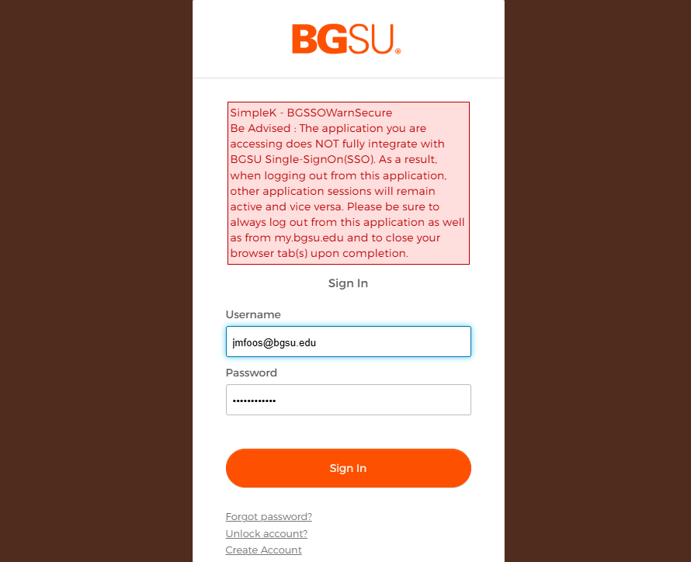
1. Standard username and password

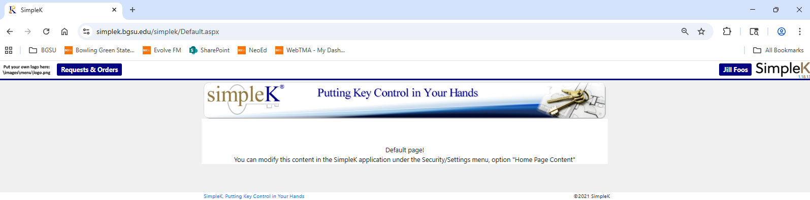
1. Click the Request & Order tab. If you do not have this tab, contact facilities @bgsu.edu or 419-372-2251

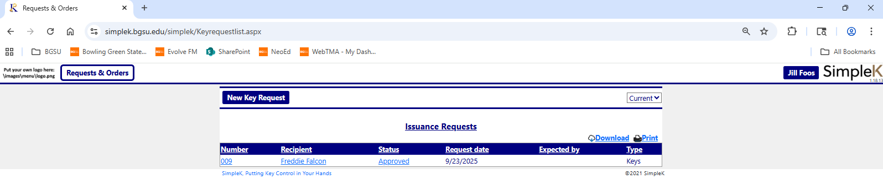
1. Click New Key Request

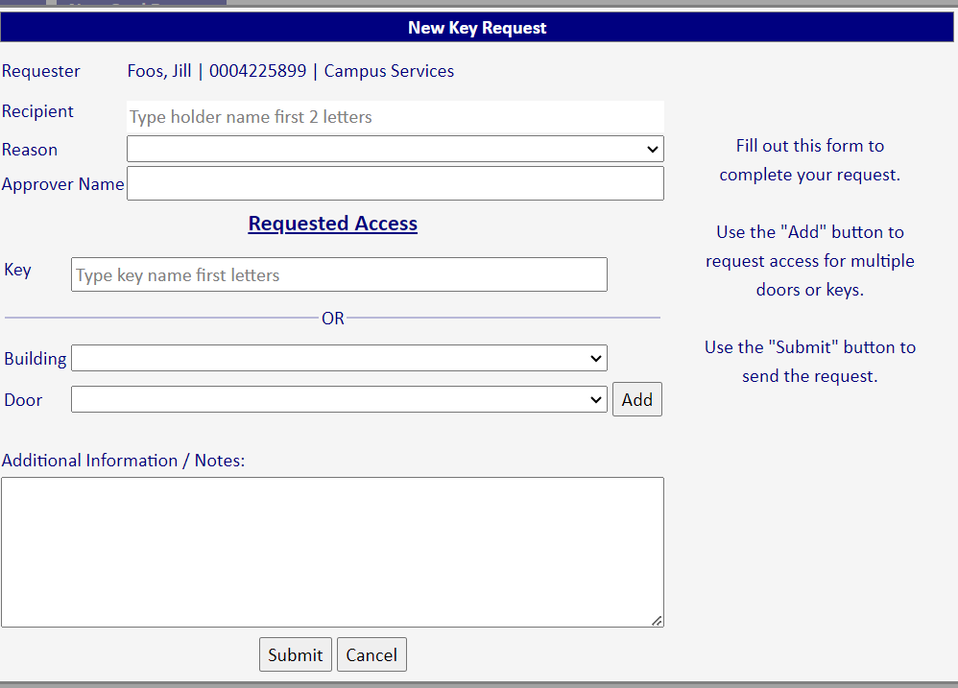
1. Start typing last name or ID # of the recipient. They must be in PeopleSoft to order keys.

2. Select a reason
3. Dean/Director/Chair of the approving department
4. Insert key number OR building and door
5. Click Add to order additional keys for the same person
6. Submit the order
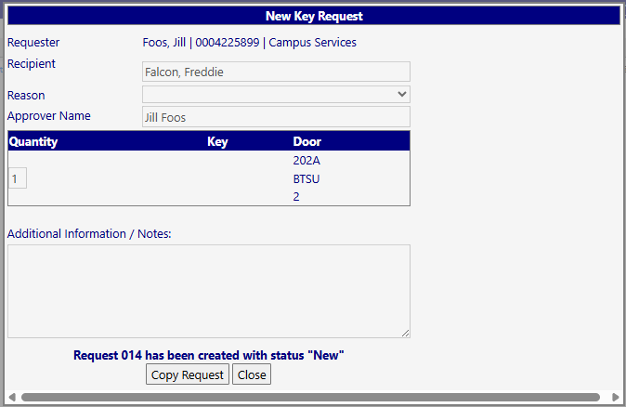
1. Order has been created
2. To order the same keys for another person Copy Request and change the recipient.

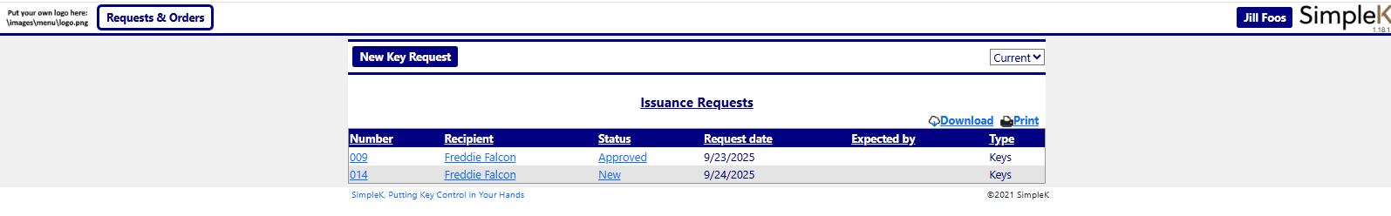
Issuance Requests will list open requests and the status of orders you have placed.
New – submitted but no action taken yet
Pending Approval – waiting on Dean/Director/Chair to approve
Approved – Dean/Director/Chair has approved the order
Processing – keys are being prepared or waiting to be picked up
An email is sent to the recipient when keys are ready to pick up
Once keys are picked up the issuance request will no longer appear on the list

Once a key order is placed Campus Operations will forward it to the Dean/Director/Chair for electronic approval. The approver will receive an email with a link to approve the order.

