Key Order Approval Process: SimpleK Web
Approver will receive an email notification to approve request or use this link https://simplek.bgsu.edu/simplek/Keyrequestlist.aspx
1. Click Site to get to the approval webpage

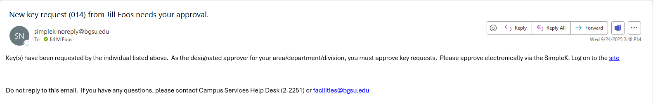

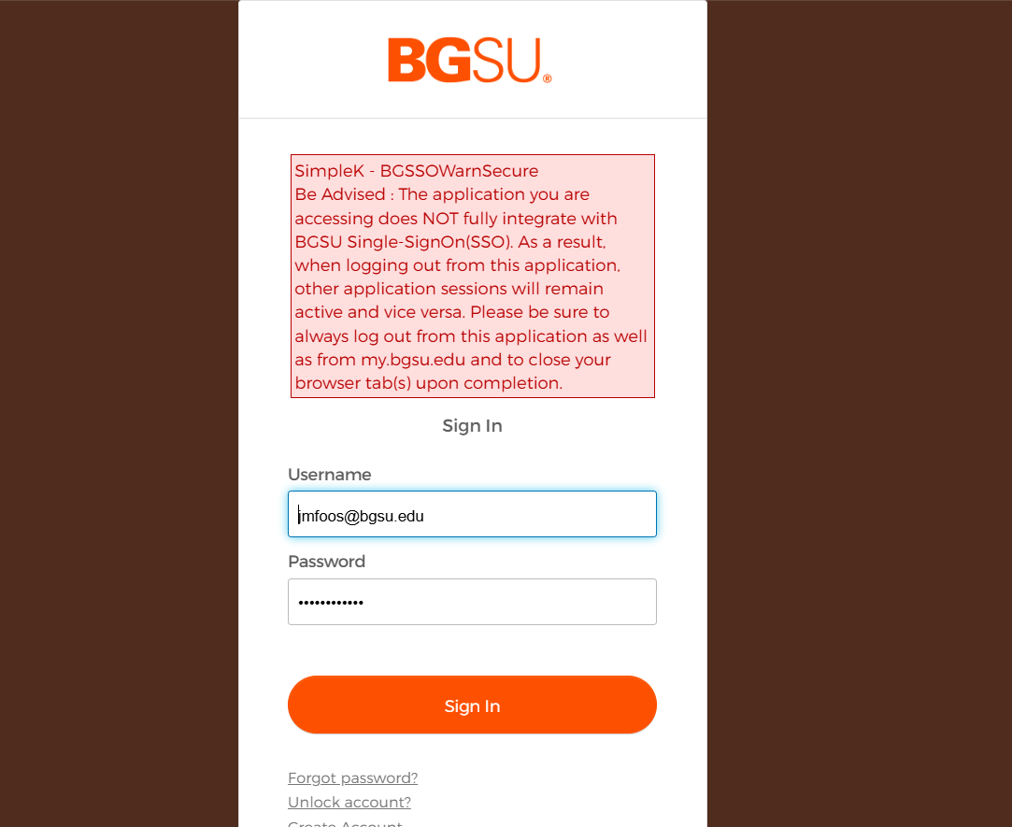
1. Standard username and password
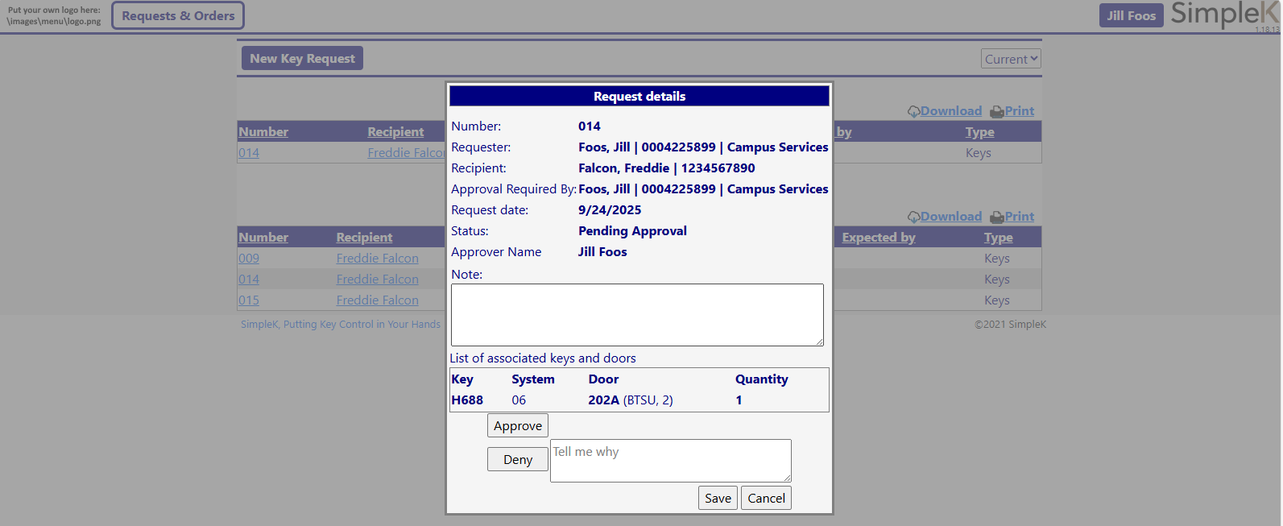
1. Approve or deny the request.
2. Save

